Answers to Questions

1. A job order cost system is best suited to manufacturing operations that produce distinct products or products that are produced in distinct batches. Examples include buildings, ships, and airplanes. It is also suited to many service operations such as auditing and legal services.

2. A process cost system is best suited to manufacturing operations that produce homogeneous products in a continuous production process. Examples include paint, gasoline, and soft drinks.

3. In a job order cost system there are overhead costs that cannot be directly traced to particular jobs. Indirect material, utilities, and depreciation costs are examples of costs that are added together and averaged over the products through the use of some common measure of production. Averaging is used further in a job order system when numbers of units on a particular job are organized into a batch. The total cost of the batch is divided by the number of units in the batch to determine the average unit cost. In a process cost system the per unit product cost is determined for each processing department by dividing the total product cost incurred in the department by the number of units of product made in the department during some designated span of time. Accordingly, an average unit cost is determined.

4. A unit cost is determined for each processing department by dividing the department’s total production costs for the period by the department’s total number of equivalent units for the period. The unit cost of each department becomes the transferred-in unit cost for the subsequent department. Accordingly, the production costs of the preceding departments become a part of the production costs of the subsequent departments. Ultimately, the final unit cost is the unit cost determined for the last processing department. It is computed by dividing the total production costs incurred for all departments by the total number of equivalent units in the last department.

5. Ludwig can use a job order cost system to accumulate the costs related to the special order. Job order and process cost systems are not incompatible. Companies can use job order systems for some products and a process cost system for other products.

6. Job order cost systems require more documentation because cost information must be traced to each specific job. In a process cost system there is less tracing of costs to products and more averaging.

7. Source documents provide accountants with initial data from operating departments such as production and warehouse. Examples of source documents include material requisition forms and work tickets. Accountants use material requisition forms to identify the cost of materials used and work tickets to identify additional cost of direct labor. Without the source documents, accountants are not able to obtain the data needed for product costs.

8. The subsidiary records for work-in-process inventory are called job cost sheets. The materials, labor, and overhead costs for a job are summarized on the job cost sheet.

9. Indirect labor is normally recorded in the manufacturing overhead account and allocated to work-in-process inventory using a predetermined overhead rate. Indirect labor is assigned to each job by using the predetermined overhead rate to allocate overhead from work-in-process to the job cost sheets kept for each job in production.

10. Depreciation on manufacturing equipment is recorded initially in manufacturing overhead and accumulated depreciation. From the overhead account, the cost is allocated to work-in-process using a predetermined overhead rate. In a job order cost system the allocation is to one work-in-process account used to accumulate product costs for the company’s jobs. It is then allocated from work-in-process to the job cost sheets for each production job. Finally, it is averaged across the products being produced on each job. In a process cost system the allocation of depreciation from the overhead account goes to many different work-in-process accounts that are used to accumulate production costs for each processing department. Within each department the cost is then averaged across all products under production in the department during that period.

11. Products that are distinctly different must be designed and manufactured separately, which makes continuous production in mass quantities impossible. Under the circumstances, a process cost system is not applicable.

12. Videl should express the partially complete units as an equivalent number of complete units prior to including them in the per unit computation. For example, if 1,000 units were 25% complete, then they could be included as 250 (i.e., 1,000 x .25) complete units.

13. The company does not have 1,000 complete units. Only 600 units are completed. If unit costs are based on 1,000 units, the unit cost will be understated. The company will be including all the units (the company has the equivalent of only 800 units) in the computation but only part of the costs. To get a more accurate unit cost Bindon should convert the incomplete units to equivalent units. By using equivalent units it will be matching units with production costs.

14. The weighted average method is a method used in process costing to determine equivalent units. The method ignores the state of completion of items in beginning inventory. They are assumed to be 100% complete. The equivalent units adjustment is applied only to units in ending inventory. Using this method can distort the accuracy of unit cost resulting in inaccuracies in the allocation of production costs between departments. The method is frequently used because of its simplicity and in many cases the results do not differ significantly from more precise, but more complex, methods.

15. The three primary steps in a process cost system are as follows:

a. Determining the number of equivalent units – Incomplete units are converted into equivalent units in order to obtain an accurate unit cost.
b. Finding the cost per equivalent unit – Total production costs for each department are divided by the total number of equivalent units in that department.
c. Allocating production cost between departments – Total production costs for each department are allocated between those costs that become the department’s ending work-in-process inventory and those costs that will be transferred out to a subsequent department or finished goods. This allocation is completed by multiplying the cost per equivalent unit determined in part b by the number of equivalent units in ending inventory and by the number of units being transferred. The allocation of costs is necessary for determining the final unit cost of product produced. The unit cost is necessary for product pricing, for performance evaluation, and for control purposes. It is also necessary for financial statement purposes for determining ending inventory and cost of goods sold.

16. Transferred-in costs are the production costs associated with products that have been transferred into a department for further processing or completion. Transferred-in costs consist of the material, labor, and overhead that have been added to the products up to the point of transfer. The amount of transferred-in costs is determined by multiplying the cost per equivalent unit for the preceding department by the number of units being transferred out of the preceding department.

17. The transferred-in costs include the costs incurred by the departments preceding finishing and may have been incurred in preceding months. These costs were transferred out of the printing department at the end of February. They become the transferred-in costs to the finishing department in the month of March.

Exercise 12-1B

Type of Product | Type of Cost System
a. Audit engagement | Job-Order
b. Shoes | Process
c. Treadmill | Process
d. Textbook | Job-Order
e. House | Job-Order
f. Oil | Process
g. Luxury yacht | Hybrid
h. Special-order personal computer | Hybrid
i. Over-the-counter personal computer | Process
j. Mouse pad for a computer | Process
k. Aircraft carrier | Job-Order
l. Makeup sponge | Process
m. Hand-held video game player | Process
n. Generic coffee mug | Process
o. Personalized coffee mug | Hybrid
p. Surgery | Job-Order

Exercise 12-2B

Morgan Corporation’s Knox Plant produces a weed-control chemical solution, Weed Terminator, in a continuous and uniform process. All bottles of Weed Terminator have the same content and cost. For this type of production, a process cost system is the most appropriate.

Exercise 12-3B

a. Even though the subject of each portrait Ms. Gill would draw is different, the process and technique she uses is basically the same. Ms. Gill could consider framing a separate product which also follows a standard production procedure. Consequently, a process cost system is appropriate.

b. Ms. Gill’s costs could include the following:

Direct materials: | paper, frame
Direct labor: | Ms. Gill’s time for each portrait
Manufacturing Overhead: | lease cost for stand, paint, brush, and pencils

c. Ms. Gill would have to do some marketing research to learn what actually attracts customers so she could estimate the number of portraits she would likely draw for customers in a month. Price, quality, location, and an individual artist’s style and personality could influence demand. She would have to consider all such factors to make the best estimate for her own business. After she operates her business for a couple of months, Ms. Gill would be able to refine her estimate using actual market history. The refined estimate would provide a reasonable base for estimating overhead per portrait.

Total manufacturing overhead costs are the sum of the monthly lease and the monthly costs of replacing various art supplies. The manufacturing overhead rate is total monthly manufacturing overhead costs divided by the estimated number of portraits per month.

d. Ms. Gill would be self-employed. Her time spent drawing portraits is comparable to that of any other hired artist doing the same work. Therefore, she would have labor cost.

Exercise 12-4B

a.

Assets |  |  |  |  |  |  |  | = | Equity
 |  |  | Work in |  | Finished |  | Manuf. |  | Com. |  | Ret.
Cash |  | + | Process | + | Goods | + | OH | = | Stock | + | Ear. |  | Rev. | – | Exp. | = | Net Inc. |  | Cash Flow
40,000 |  | + | N/A | + | N/A | + | N/A | = | 40,000 | + | N/A |  | N/A | – | N/A | = | N/A |  | 40,000 FA
(7,360) |  | + | 7,360 | + | N/A | + | N/A | = | N/A | + | N/A |  | N/A | – | N/A | = | N/A |  | (7,360) OA
(10,240) |  | + | 10,240 | + | N/A | + | N/A | = | N/A | + | N/A |  | N/A | – | N/A | = | N/A |  | (10,240) OA
(5,200) |  | + | 5,200 | + | N/A | + | N/A | = | N/A | + | N/A |  | N/A | – | N/A | = | N/A |  | (5,200) OA
(6,800) |  | + | 6,800 | + | N/A | + | N/A | = | N/A | + | N/A |  | N/A | – | N/A | = | N/A |  | (6,800) OA
(14,400) |  | + | N/A | + | N/A | + | 14,400 | = | N/A | + | N/A |  | N/A | – | N/A | = | N/A |  | (14,400) OA
N/A |  | + | 6,144 | + | N/A | + | (6,144) | = | N/A | + | N/A |  | N/A | – | N/A | = | N/A |  | N/A
N/A |  | + | 4,080 | + | N/A | + | (4,080) | = | N/A | + | N/A |  | N/A | – | N/A | = | N/A |  | N/A
N/A |  | + | (23,744) | + | 23,744 | + | N/A | = | N/A | + | N/A |  | N/A | – | N/A | = | N/A |  | N/A
28,000 |  | + | N/A | + | N/A | + | N/A | = | N/A | + | 28,000 |  | 28,000 | – | N/A | = | 28,000 |  | 28,000 OA
N/A |  | + | N/A | + | (23,744) | + | N/A | = | N/A | + | (23,744) |  | N/A | – | 23,744 | = | (23,744) |  | N/A
24,000 |  | + | 16,080 | + | 0 | + | 4,176 | = | 40,000 | + | 4,256 |  | 28,000 | – | 23,744 | = | 4,256 |  | 24,000 NC

Exercise 12-4B (continued)

Predetermined manufacturing overhead rate:

$240,000/20,000 = $12 per direct labor hour

Applied manufacturing overhead for Job 801:
$12 x 512 = $6,144

Applied manufacturing overhead for Job 802:
$12 x 340 = $4,080

Items | Job 801 | Job 802
Direct materials | $ 7,360 | $ 5,200
Direct labor | 10,240 | 6,800
Manufacturing overhead | 6,144 | 4,080
Total product cost | $23,744 | $16,080

b. The amount of ending inventory on August 31st was $16,080, which is the current balance of Job 802. This is an estimate because the applied manufacturing overhead cost included in the job cost is an estimate.

c. It is appropriate to use estimated cost on the balance sheet when the difference between applied and actual overhead is insignificant. Under these circumstances any difference between applied and actual overhead would be closed directly to cost of goods sold and inventory would be reported at estimated cost.
Exercise12-5B
a. & b.

Assets |  |  |  |  |  |  | = | Equity
 |  | Work in |  | Finished |  | Manuf. |  | Com. |  | Ret.
Cash | + | Process | + | Goods | + | OH | = | Stock | + | Ear. |  | Rev. | – | Exp. | = | Net Inc. |  | Cash Flow
48,000 | + | N/A | + | N/A | + | N/A | = | 48,000 | + | N/A |  | N/A | – | N/A | = | N/A |  | 48,000 FA
(3,600) | + | 3,600 | + | N/A | + | N/A | = | N/A | + | N/A |  | N/A | – | N/A | = | N/A |  | (3,600) OA
(14,400) | + | 14,400 | + | N/A | + | N/A | = | N/A | + | N/A |  | N/A | – | N/A | = | N/A |  | (14,400) OA
(6,480) | + | 6,480 | + | N/A | + | N/A | = | N/A | + | N/A |  | N/A | – | N/A | = | N/A |  | (6,480) OA
(21,600) | + | 21,600 | + | N/A | + | N/A | = | N/A | + | N/A |  | N/A | – | N/A | = | N/A |  | (21,600) OA
(5,840) | + | 5,840 | + | N/A | + | N/A | = | N/A | + | N/A |  | N/A | – | N/A | = | N/A |  | (5,840) OA
(19,040) | + | 19,040 | + | N/A | + | N/A | = | N/A | + | N/A |  | N/A | – | N/A | = | N/A |  | (19,040) OA
(24,080) | + | N/A | + | N/A | + | 24,080 | = | N/A | + | N/A |  | N/A | – | N/A | = | N/A |  | (24,080) OA
N/A | + | 7,200 | + | N/A | + | (7,200) | = | N/A | + | N/A |  | N/A | – | N/A | = | N/A |  | N/A
N/A | + | 5,760 | + | N/A | + | (5,760) | = | N/A | + | N/A |  | N/A | – | N/A | = | N/A |  | N/A
N/A | + | 10,880 | + | N/A | + | (10,880) | = | N/A | + | N/A |  | N/A | – | N/A | = | N/A |  | N/A
N/A | + | (25,200) | + | 25,200 | + | N/A | = | N/A | + | N/A |  | N/A | – | N/A | = | N/A |  | N/A
N/A | + | (33,840) | + | 33,840 | + | N/A | = | N/A | + | N/A |  | N/A | – | N/A | = | N/A |  | N/A
30,400 | + | N/A | + | N/A | + | N/A | = | N/A | + | 30,400 |  | 30,400 | – | N/A | = | 30,400 |  | 30,400 OA
N/A | + | N/A | + | (25,200) | + | N/A | = | N/A | + | (25,200) |  | N/A | – | 25,200 | = | (25,200) |  | N/A
43,200 | + | N/A | + | N/A | + | N/A | = | N/A | + | 43,200 |  | 43,200 | – | N/A | = | 43,200 |  | 43,200 OA
N/A | + | N/A | + | (33,840) | + | N/A |  | N/A | + | (33,840) |  | N/A | – | 33,840 | = | (33,840) |  | N/A
(8,000) | + | N/A | + | N/A | + | N/A | = | N/A | + | (8,000) |  | N/A | – | 8,000 | = | (8,000) |  | (8,000) OA
N/A | + | N/A | + | N/A | + | (240) | = | N/A | + | (240) |  | N/A | – | 240 | = | (240)
18,560 | + | 35,760 | + | 0 | + | 0 | = | 48,000 | + | 6,320 |  | 73,600 | – | 67,280 | = | 6,320 |  | 18,560 NC

Exercise12-5B (continued)

Items | Job 301 | Job 302 | Job 303
Direct materials | $ 3,600 | $ 6,480 | $ 5,840
Direct labor | 14,400 | 21,600 | 19,040
Manufacturing overhead | 7,200 | 5,760 | 10,880
Total product cost | $25,200 | $33,840 | $35,760

Total applied manufacturing overhead:
$7,200 + $5,760 + $10,880 = $23,840

Total actual MOH – Total applied MOH = Underapplied MOH
$24,080 – $23,840 = $240

c. Sales revenue – Cost of goods sold = Gross margin

($30,400 + $43,200) – ($25,200 + $33,840 + $240) = $14,320

Exercise 12-6B

a. The costs of Contract 3 follow:

Direct labor | $28,800
Overhead* | 12,960
Total | $41,760
*Predetermined overhead rate:
$21,600 ÷ $48,000 = $0.45 per direct labor cost dollar.
$0.45 x $28,800 = $12,960

The amount of income earned from Contract 3 is $23,840 ($65,600 − $41,760).

b. Lanzi is a service business that does not produce inventory. It will therefore not report finished goods inventory on the balance sheet.

Exercise 12-7B

The cost of job order 712 is shown below:

Materials | $31,000
Labor | 19,000
Overhead | 22,000
Total | $72,000

Contract price | ?
Cost of job | $72,000
Gross profit | $25,000
Contract price = Gross profit + Cost of job
= $25,000 + $72,000 = $97,000

Exercise 12-8B

a.
Quantities | Actual | Equivalent Units
Beginning inventory | 1,500
Units added to production | 18,000
Total to be accounted for | 19,500
Transferred to finished goods | 13,500 ⁽¹⁾ | x 100% | 13,500
Ending inventory | 6,000 | x 40% | 2,400
Total accounted for | 19,500 |  | 15,900
⁽¹⁾19,500 − 6,000 = 13,500

b.
Quantities | Actual | Equivalent Units
Beginning inventory | 1,500
Units added to production | 18,000
Total to be accounted for | 19,500
Transferred to finished goods | 13,500 ⁽¹⁾ | x 100% | 13,500
Ending inventory | 6,000 | x 25%⁽³⁾ | 1,500⁽²⁾
Total accounted for | 19,500 |  | 15,000
⁽¹⁾ 19,500 − 6,000 = 13,500
⁽²⁾ 15,000 − 13,500 = 1,500
⁽³⁾ 6,000X = 1,500; X = 25%

Exercise 12-9B

a. and b.

Cost per Unit
Cost Accumulation
Beginning inventory | $ 75,000
Raw materials cost | 420,000
Labor cost | 240,000
Overhead cost | 165,000
Total to be accounted for | $900,000
Cost per unit | $900,000 | ÷ 18,000 | = $50
Part a: Cost Allocation
To finished goods (15,000* units x $50) |  |  | $750,000
To ending inventory (3,000 equivalent units x $50) |  |  | 150,000
Total allocated cost |  |  | $900,000
*18,000 − 3,000 = 15,000
Part b: Cost Allocation
To finished goods (14,000 units x $50) |  |  | $ 700,000
To ending inventory (4,000* equivalent units x $50) |  |  | 200,000
Total allocated cost |  |  | $900,000
*18,000 − 14,000 = 4,000

Exercise 12-10B

a., b., and c.
Equivalent Units
Transferred to finished goods |  | 21,000 | x 100% | 21,000
Ending inventory |  | 3,000 | x 40% | 1,200
Total accounted for |  | 24,000 |  | 22,200
Cost per Unit
Cost per equivalent unit |  | $666,000 | ÷ 22,200 | = $30
Cost Allocation
To finished goods (21,000 units x $30) |  |  |  | $630,000
To ending inventory (1,200 equivalent units x $30) |  |  |  | 36,000
Total allocated cost |  |  |  | $666,000

Exercise 12-11B

WIP Binding
Bal. 30,000 | 360,000 Transferred out
Transferred in ?
Materials 11,000
Labor 38,000
Overhead 71,000
Bal. 53,000

$30,000+X+$11,000+$38,000+$71,000 − 360,000 =$53,000
X = $263,000

Exercise 12-12B

a. Foxwell is a manufacturing company because it produces such tangible products as altered equipment that adds value to vehicles.
b. A job-order cost system would be most appropriate for Foxwell. Each customer’s needs are unique and, hence, individual products are different. A job-order cost system would allow Foxwell to track the costs incurred on behalf of each customer.
c. Foxwell does have work in process inventory and finished goods inventory. Foxwell should account for every incomplete job as work in process. Every job completed but not yet delivered to customers is finished goods inventory.
d. Foxwell should classify engineering design costs as manufacturing overhead because it develops designs before customers agree to a contract. Therefore, some design costs will result in revenues and others will not be recovered.

Problem 12-13B a., b., and c. (reference numbers are provided to facilitate the tracing of transactions)

 | Assets |  |  |  |  |  |  |  |  |  | Equity |  |  |  | Rev. | – | Exp. | = | Net Inc. |  | Cash Flow
 | Cash | + | Raw. M. | + | MOH | + | W-I-P | + | F. Goods | = | C. Stk. | + | Ret. Ear.
 | 40,000 | + | N/A | + | N/A | + | N/A | + | N/A | = | 40,000 | + | N/A |  | N/A | – | N/A | = | N/A |  | 40,000 FA
 | (7,900) | + | 7,900 | + | N/A | + | N/A | + | N/A | = | N/A | + | N/A |  | N/A | – | N/A | = | N/A |  | (7,900) OA
 | N/A | + | (2,100) | + | N/A | + | 2,100 | + | N/A | = | N/A | + | N/A |  | N/A | – | N/A | = | N/A |  | N/A
 | (3,200) | + | N/A | + | N/A | + | 3,200 | + | N/A | = | N/A | + | N/A |  | N/A | – | N/A | = | N/A |  | (3,200) OA
 | N/A | + | (1,700) | + | N/A | + | 1,700 | + | N/A | = | N/A | + | N/A |  | N/A | – | N/A | = | N/A |  | N/A
 | (4,800) | + | N/A | + | N/A | + | 4,800 | + | N/A | = | N/A | + | N/A |  | N/A | – | N/A | = | N/A |  | (4,800) OA
 | N/A | + | (3,200) | + | N/A | + | 3,200 | + | N/A | = | N/A | + | N/A |  | N/A | – | N/A | = | N/A |  | N/A
 | (4,480) | + | N/A | + | N/A | + | 4,480 | + | N/A | = | N/A | + | N/A |  | N/A | – | N/A | = | N/A |  | (4,480) OA
 | N/A | + | N/A | + | (1,500) | + | 1,500 | + | N/A | = | N/A | + | N/A |  | N/A | – | N/A | = | N/A |  | N/A
 | N/A | + | N/A | + | (2,250) | + | 2,250 | + | N/A | = | N/A | + | N/A |  | N/A | – | N/A | = | N/A |  | N/A
 | N/A | + | N/A | + | (2,100) | + | 2,100 | + | N/A | = | N/A | + | N/A |  | N/A | – | N/A | = | N/A |  | N/A
 | N/A | + | N/A | + | N/A | + | (6,800) | + | 6,800 | = | N/A | + | N/A |  | N/A | – | N/A | = | N/A |  | N/A
 | N/A | + | N/A | + | N/A | + | (9,780) | + | 9,780 | = | N/A | + | N/A |  | N/A | – | N/A | = | N/A |  | N/A
 | 9,800 | + | N/A | + | N/A | + | N/A | + | N/A | = | N/A | + | 9,800 |  | 9,800 | – | N/A | = | 9,800 |  | 9,800 OA
 | N/A | + | N/A | + | N/A | + | N/A | + | (6,800) | = | N/A | + | (6,800) |  | N/A | – | 6,800 | = | (6,800) |  | N/A
 | (1,400) | + | N/A | + | N/A | + | N/A | + | N/A | = | N/A | + | (1,400) |  | N/A | – | 1,400 | = | (1,400) |  | (1,400) OA
 | (6,000) | + | N/A | + | 6,000 | + | N/A | + | N/A | = | N/A | + | N/A |  | N/A | – | N/A | = | N/A |  | (6,000) OA
 | N/A | + | N/A | + | (150) | + | N/A | + | N/A | = | N/A | + | (150) |  | N/A | – | 150 | = | (150) |  | N/A
 | 22,020 | + | 900 | + | 0 | + | 8,750 | + | 9,780 | = | 40,000 | + | 1,450 |  | 9,800 | – | 8,350 | = | 1,450 |  | 22,020

Items | Job 1 | Job 2 | Job 3
Direct materials | $2,100 | $ 1,700 | $ 3,200
Direct labor (a) | 3,200 | 4,800 | 4,480
Manufacturing overhead (a ÷ 16) x $7.50 | 1,500 | 2,250 | 2,100
Total product cost | $6,800 | $8,750 | $9,780

Problem 12-13B (continued)
d.
Schiller Corporation
Financial Statements for 2006
Cost of Goods Manf. and Sold |  |  | Income Statement |  |  | Balance Sheet |  |  | Statement of Cash Flows
Beg. Raw Mat. Inv. | $ 0 |  | Sales Revenue | $9,800 |  | Assets |  |  | Oper. Activities
Purchases | 7,900 |  | Cost of Goods Sold | (6,950) |  | Cash | $22,020 |  | Inflow from Rev. | $ 9,800
Raw Mat. Avail. | 7,900 |  | Gross Margin | 2,850 |  | Raw Mat. Inv. | 900 |  | Outflow for Inventory | (26,380)
End Raw Mat. Inv. | (900) |  | Selling and Admin. | (1,400) |  | W-I-P Inv. | 8,750 |  | Outflow for S & A Exp. | (1,400)
Raw Mat. Used | 7,000 |  | Net Income | $1,450 |  | Fin. Goods Inv. | 9,780 |  | Net Outflow from Oper. | (17,980)
Labor | 12,480 |  |  |  |  | Total Assets | $41,450 |  | Investing Activities | 0
Overhead | 6,000 |  |  |  |  |  |  |  | Financing Activities
Total Manf. Costs | 25,480 |  |  |  |  |  |  |  | Inflow from Stock Issue | 40,000
Beg. W-I-P Inv. | 0 |  |  |  |  | Equity |  |  | Net Change in Cash | 22,020
Total W-I-P Inv. | 25,480 |  |  |  |  | Common Stk. | $40,000 |  | Beginning Cash Balance | 0
End. W-I-P Inv. | (8,750) |  |  |  |  | Ret. Earnings | 1,450 |  | Ending Cash Balance | $22,020
Cost of Goods Man. | 16,730 |  |  |  |  | Total Equity | $41,450
Beg. Fin. Goods | 0
Goods Available | 16,730
End. Fin. Goods | (9,780)
Cost of Goods Sold | $ 6,950

Problem 12-14B a., b., and c.

 | Assets |  |  |  |  |  |  |  |  |  | Equity |  |  |  | Rev. | – | Exp. | = | Net Inc. |  | Cash Flow
 | Cash | + | Raw. M. | + | MOH | + | W-I-P | + | F. Goods | = | C. Stk. | + | Ret. Ear.
 | 2,800 | + | N/A | + | N/A | + | N/A | + | N/A | = | 2,800 | + | N/A |  | N/A | – | N/A | = | N/A |  | 2,800 FA
 | (2,400) | + | 2,400 | + | N/A | + | N/A | + | N/A | = | N/A | + | N/A |  | N/A | – | N/A | = | N/A |  | (2,400) OA
 | N/A | + | (2,160) | + | N/A | + | 2,160 | + | N/A | = | N/A | + | N/A |  | N/A | – | N/A | = | N/A |  | N/A
 | (640) | + | N/A | + | N/A | + | 640 | + | N/A | = | N/A | + | N/A |  | N/A | – | N/A | = | N/A |  | (640) OA
 | N/A | + | N/A | + | (520) | + | 520 | + | N/A | = | N/A | + | N/A |  | N/A | – | N/A | = | N/A |  | N/A
 | (176) | + | N/A | + | 176 | + | N/A | + | N/A | = | N/A | + | N/A |  | N/A | – | N/A | = | N/A |  | (176) OA
 | (240) | + | N/A | + | 240 | + | N/A | + | N/A | = | N/A | + | N/A |  | N/A | – | N/A | = | N/A |  | (240) OA
 | (144) | + | N/A | + | 144 | + | N/A | + | N/A | = | N/A | + | N/A |  | N/A | – | N/A | = | N/A |  | (144) OA
 | N/A | + | N/A | + | N/A | + | (1,090) | + | 1,090 | = | N/A | + | N/A |  | N/A | – | N/A | = | N/A |  | N/A
 | N/A | + | N/A | + | N/A | + | (574) | + | 574 | = | N/A | + | N/A |  | N/A | – | N/A | = | N/A |  | N/A
 | 2,160 | + | N/A | + | N/A | + | N/A | + | N/A | = | N/A | + | 2,160 |  | 2,160 | – | N/A | = | 2,160 |  | 2,160 OA
 | N/A | + | N/A | + | N/A | + | N/A | + | (1,090) | = | N/A | + | (1,090) |  | N/A | – | 1,090 | = | (1,090) |  | N/A
 | (496) | + | N/A | + | N/A | + | N/A | + | N/A | = | N/A | + | (496) |  | N/A | – | 496 | = | (496) |  | (496) OA
 | N/A | + | N/A | + | (40) | + | N/A | + | N/A | = | N/A | + | (40) |  | N/A | – | 40 | = | (40) |  | N/A
 | 864 | + | 240 | + | 0 | + | 1,656 | + | 574 | = | 2,800 | + | 534 |  | 2,160 | – | 1,626 | = | 534 |  | 864

Items | Roof 1 | Roof 2 | Roof 3
Direct materials | $ 800 | $400 | $ 960
Direct labor | 160 | 96 | 384
Manufacturing overhead | 130 | 78 | 312
Total product cost | $1,090 | $574 | $1,656
Problem 12-14B (continued)
d.

Kearney Roofing Corporation
Financial Statements for 2007
Cost of Goods Manf. and Sold |  |  | Income Statement |  |  | Balance Sheet |  |  | Statement of Cash Flows
Beg. Raw Mat. Inv. | $ 0 |  | Sales Revenue | $2,160 |  | Assets |  |  | Oper. Activities
Purchases | 2,400 |  | Cost of Goods Sold | (1,130) |  | Cash | $ 864 |  | Inflow from Rev. | $2,160
Raw Mat. Avail. | 2,400 |  | Gross Margin | 1,030 |  | Raw Mat. Inv. | 240 |  | Outflow for Inventory | (3,600)
End. Raw Mat. Inv. | (240) |  | S & A Exp. | (496) |  | W-I-P Inv. | 1,656 |  | Outflow for S & A Exp. | (496)
Raw Mat. Used | 2,160 |  | Net Income | $ 534 |  | Fin. Goods Inv. | 574 |  | Net Outflow from Oper. | (1,936)
Labor | 640 |  |  |  |  | Total Assets | $3,334 |  | Investing Activities | 0
Overhead | 560 |  |  |  |  |  |  |  | Financing Activities
Total Manf. Costs | 3,360 |  |  |  |  | Equity |  |  | Inflow from Stock Issue | 2,800
Beg. W-I-P Inv. | 0 |  |  |  |  | Common Stk. | 2,800 |  | Net Change in Cash | 864
Total W-I-P Inv. | 3,360 |  |  |  |  | Ret. Earnings | 534 |  | Beginning Cash Balance | 0
End. W-I-P Inv. | (1,656) |  |  |  |  | Total Equity | $3,334 |  | Ending Cash Balance | $ 864
Cost of Goods Man. | 1,704
Beg. Fin. Goods | 0
Goods Available | 1,704
End. Fin. Goods | (574)
Cost of Goods Sold | $1,130

Problem 12-15B a., b., and c.

Cash |  |  | Work-in-Process  Processing |  |  | Work-in-Process  Packaging |  |  | Finished Goods |  |  | Common Stock
(1) 80,000 | (2) 42,000 |  | (3) 38,000 | (7) 60,500 |  | (4) 25,500 | (8) 70,000 |  | (8) 70,000 | (9) 63,000 |  |  | (1) 80,000
(9) 117,500 | (2) 7,500 |  | (4) 32,500 |  |  | (5) 20,400 |  |  | Bal 7,000
 | (4) 77,000 |  | (5) 26,000 |  |  | (7) 60,500
 | (6) 22,500 |  | Bal 36,000 |  |  | Bal 36,400 |  |  |  |  |  | Retained Earnings
 | (10) 23,500 |  |  |  |  |  |  |  |  |  |  |  | Cl 31,400
Bal 25,000
Raw Materials |  |  |  |  |  |  |  |  |  |  |  | Revenue
(2) 42,000 | (3) 38,000 |  |  |  |  |  |  |  |  |  |  | Cl 117,500 | (9) 117,500
Bal 4,000
Production Supplies |  |  |  |  |  |  |  |  |  |  |  | Cost of Goods Sold
(2) 7,500 | (11) 4,500 |  |  |  |  |  |  |  |  |  |  | (9) 63,000 | (12) 400
Bal 3,000 |  |  |  |  |  |  |  |  |  |  |  |  | Cl 62,600
Manufacturing Overhead
(4) 19,000 | (5) 46,400 |  |  |  |  |  |  |  |  |  |  | Selling & Admin. Exp.
(6) 22,500 |  |  |  |  |  |  |  |  |  |  |  | (10) 23,500 | Cl 23,500
(11) 4,500
(12) 400
Bal 0

Problem 12-15B (continued)
d.

Chaplin Food Company
Financial Statements for 2006
Cost of Goods Manf. and Sold |  |  | Income Statement |  |  | Balance Sheet |  |  | Statement of Cash Flows
Beg. Raw Mat. Inv. | $ 0 |  | Sales Revenue | $117,500 |  | Assets |  |  | Oper. Activities
Purchases | 42,000 |  | Cost of Goods Sold | (62,600) |  | Cash | $ 25,000 |  | Inflow from Rev. | $117,500
Raw Mat. Avail. | 42,000 |  | Gross Margin | 54,900 |  | Production Sup. | 3,000 |  | Outflow for Inventory | (149,000)
End. Raw Mat. Inv. | (4,000) |  | Sell & Admin. Exp. | (23,500) |  | Raw Mat. Inv. | 4,000 |  | Outflow for Sell. & Adm. | (23,500)
Raw Mat. Used | 38,000 |  | Net Income | $ 31,400 |  | W-I-P Inv. | 72,400 |  | Net Outflow from Oper. | (55,000)
Labor | 58,000 |  |  |  |  | Fin. Goods Inv. | 7,000 |  | Investing Activities | 0
Overhead | 46,000 |  |  |  |  | Total Assets | $111,400 |  | Financing Activities
Total Manf. Costs | 142,000 |  |  |  |  |  |  |  | Inflow from Stock Issue | 80,000
Beg. W-I-P Inv. | 0 |  |  |  |  | Equity |  |  | Net Change in Cash | 25,000
Total W-I-P Inv. | 142,000 |  |  |  |  | Common Stk. | $80,000 |  | Beginning Cash Balance | 0
End. W-I-P Inv. | (72,400) |  |  |  |  | Ret. Earnings | 31,400 |  | Ending Cash Balance | $25,000
Cost of Goods Man. | 69,600 |  |  |  |  | Total Equity | $111,400
Beg. Fin. Goods | 0
Goods Available | 69,600
End. Fin. Goods | (7,000)
Cost of Goods Sold | $62,600

Problem 12-16B a., b., and c.

Cash |  |  | Work-in-Process  Processing |  |  | Work-in-Process  Packaging |  |  | Finished Goods |  |  | Common Stock
Bal 25,000 | (1) 51,000 |  | Bal 36,000 | (6) 125,000 |  | Bal 36,400 | (7) 175,000 |  | Bal 7,000 | (8) 171,000 |  |  | Bal 80,000
(8) 325,000 | (1) 9,000 |  | (2) 41,000 |  |  | (3) 29,500 |  |  | (7) 175,000
 | (3) 89,500 |  | (3) 36,000 |  |  | (4) 23,600 |  |  | Bal 11,000
 | (5) 25,000 |  | (4) 28,800 |  |  | (6) 125,000 |  |  |  |  |  | Retained Earnings
 | (9) 32,000 |  | Bal 16,800 |  |  | Bal 39,500 |  |  |  |  |  |  | Bal 31,400
Bal 143,500 |  |  |  |  |  |  |  |  |  |  |  |  | Cl 115,400
 |  |  |  |  |  |  |  |  |  |  |  |  | Bal 146,800
Raw Materials
Bal 4,000 | (2) 41,000 |  |  |  |  |  |  |  |  |  |  | Revenue
(1) 51,000 |  |  |  |  |  |  |  |  |  |  |  | Cl 325,000 | (8) 325,000
Bal 14,000
Production Supplies |  |  |  |  |  |  |  |  |  |  |  | Cost of Goods Sold
Bal 3,000 | (10) 10,000 |  |  |  |  |  |  |  |  |  |  | (8) 171,000
(1) 9,000 |  |  |  |  |  |  |  |  |  |  |  | (11) 6,600 | Cl 177,600
Bal 2,000
Manufacturing Overhead |  |  |  |  |  |  |  |  |  |  |  | Selling & Admin. Exp.
(3) 24,000 | (4) 52,400 |  |  |  |  |  |  |  |  |  |  | (9) 32,000 | Cl 32,000
(5) 25,000
(10) 10,000
 | (11) 6,600
Bal 0
Problem 12-16B (continued)

d.
Chaplkin Food Company
Financial Statements for 2007
Cost of Goods Manf. and Sold |  |  | Income Statement |  |  | Balance Sheet |  |  | Statement of Cash Flows
Beg. Raw Mat. Inv. | $ 4,000 |  | Sales Revenue | $325,000 |  | Assets |  |  | Oper. Activities
Purchases | 51,000 |  | Cost of Goods Sold | (177,600) |  | Cash | $143,500 |  | Inflow from Rev. | $325,000
Raw Mat. Avail. | 55,000 |  | Gross Margin | 147,400 |  | Production Sup. | 2,000 |  | Outflow for Inventory | (174,500)
End. Raw Mat. Inv. | (14,000) |  | Sell & Admin. Exp. | (32,000) |  | Raw Mat. Inv. | 14,000 |  | Outflow for Sell. & Adm. | (32,000)
Raw Mat. Used | 41,000 |  | Net Income | $115,400 |  | W-I-P Inv. | 56,300 |  | Net Inflow from Oper. | 118,500
Labor | 65,500 |  |  |  |  | Fin. Goods Inv. | 11,000 |  | Investing Activities | 0
Overhead | 59,000 |  |  |  |  | Total Assets | $226,800 |  | Financing Activities | 0
Total Manf. Costs | 165,500 |  |  |  |  |  |  |  | Net Change in Cash | 118,500
Beg. W-I-P Inv. | 72,400 |  |  |  |  | Equity |  |  | Beginning Cash Balance | 25,000
Total W-I-P Inv. | 237,900 |  |  |  |  | Common Stk. | $80,000 |  | Ending Cash Balance | $143,500
End. W-I-P Inv. | (56,300) |  |  |  |  | Ret. Earnings | 146,800
Cost of Goods Man. | 181,600 |  |  |  |  | Total Equity | $226,800
Beg. Fin. Goods | 7,000
Goods Available | 188,600
End. Fin. Goods | (11,000)
Cost of Goods Sold | $177,600

Problem 12-17B

Cost of Production Report for Dale Company
Schedule of Equivalent Units (a.)
Quantities: | Actual |  | Equivalent Units
Beginning inventory | 1,800
Units added to production | 19,200
Total to be accounted for | 21,000
Transferred to finished goods | 15,000 |  | x 100% | 15,000
Ending inventory | 6,000 |  | x 50% | 3,000
Total accounted for | 21,000 |  |  | 18,000
Cost per Unit (b.)
Cost Accumulation
Beginning inventory | $ 9,000
Cost added to production | 108,000
Total to be accounted for | $117,000
Cost per unit | $117,000 |  | ÷ 18,000 | = $6.50
Cost Allocation (c.)
To finished goods (15,000 units x $6.50) |  |  |  | $ 97,500
To ending inventory (3,000 EQ units x $6.50) |  |  |  | 19,500
Total allocated cost |  |  |  | $117,000

Problem 12-18B

Cost of Production Report for Shabrova Company
Equivalent Units (a.)
Quantities: | Actual | Equivalent Units
Beginning inventory | 4,500
Units added to production | 24,000
Total to be accounted for | 28,500
Transferred to finished goods | 23,500 | x 100% | 23,500
Ending inventory | 5,000 | x 30% | 1,500
Total accounted for | 28,500 |  | 25,000
Cost per Unit (b.)
Cost Accumulation
Beginning inventory | $ 19,000
Cost added to production | 151,000
Total to be accounted for | $170,000
Cost per unit | $170,000 | ÷ 25,000 | = $6.80
Cost Allocation (c.)
To finished goods (23,500 units x $6.80) |  |  | $159,800
To ending inventory (1,500 EQ units x $6.80) |  |  | 10,200
Total allocated cost |  |  | $170,000

Problem 12-19B

Cost of Production Report for Putney Corporation
Cutting Department – 2006
Equivalent Units (a.)
Quantities: | Actual |  | Equivalent Units
Beginning inventory | 6,000
Units added to production | 15,000
Total to be accounted for | 21,000
Transferred to the sewing department | 16,000 |  | x 100% | 16,000
Ending inventory | 5,000 |  | x 40% | 2,000
Total accounted for | 21,000 |  |  | 18,000
Cost per Unit (b.)
Cost Accumulation
Beginning inventory | $ 17,544
Cost added to production* | 140,136
Total to be accounted for | $157,680
Cost per unit | $157,680 |  | ÷ 18,000 | = $8.76
Cost Allocation (c.)
To the sewing department (16,000 units x $8.76) |  |  |  | $140,160
To ending inventory (2,000 EQ units x $8.76) |  |  |  | 17,520
Total allocated cost |  |  |  | $157,680

*$56,136 (DM) + $67,200 (DL) + $16,800 (Applied MOH) = $140,136

Problem 12-19B
d.

Cash |  |  | Work-in-Process Cutting |  |  | Cost of Goods Sold
Bal 271,200 | (3) 67,200 |  | Bal 17,544 | (7) 140,160 |  | (9) 480
 | (3) 5,400 |  | (2) 56,136
 | (5) 7,680 |  | (3) 67,200
Bal 190,920 |  |  | (4) 16,800
 |  |  | Bal 17,520
Raw Materials |  |  | Work-in-Process Sewing
Bal 90,000 | (2) 56,136 |  | (7) 140,160
Bal 33,864 |  |  | Bal 140,160
Manufacturing Overhead
(3) 5,400 | (4) 16,800
(5) 7,680 | (9) 480
(8) 4,200
Bal 0
Production Supplies
Bal 4,200 | (8) 4,200

Problem 12-20B

Cost of Production Report for Sherman Paper Products Corporation
Printing Department – 2006
Equivalent Units (a.)
Quantities: | Actual | Equivalent Units
Beginning inventory | 300,000
Units added to production | 800,000
Total to be accounted for | 1,100,000
Transferred to the forming department | 700,000 | x 100% | 700,000
Ending inventory | 400,000 | x 50% | 200,000
Total accounted for | 1,100,000 |  | 900,000
Cost per Unit (b.)
Cost Accumulation
Beginning inventory | $ 18,000
Cost added to production* | 99,000
Total to be accounted for | $117,000
Cost per unit | $117,000 | ÷ 900,000 | = $0.13
Cost Allocation (c.)
To the forming department (700,000 units x $.13) |  |  | $ 91,000
To ending inventory (200,000 EQ units x $.13) |  |  | 26,000
Total allocated cost |  |  | $117,000

*$57,000 (DM) + $28,000 (DL) + $14,000 (MOH) = $99,000

Problem 12-20B (continued)

d.

Cash |  |  | Work-in-Process Printing |  |  | Work-in-Process Forming |  |  |  | Common Stock
Bal 50,000 | (2) 40,000 |  | Bal 18,000 | (8) 91,000 |  | (8) 91,000 |  |  |  |  | Bal 90,500
(1) 110,000 | (2) 3,500 |  | (3) 57,000 |  |  |  |  |  |  |  | (1) 110,000
 | (4) 31,000 |  | (4) 28,000 |  |  |  |  |  |  |  | Bal 200,500
 | (6) 7,400 |  | (5) 14,000
Bal 78,100 |  |  | Bal 26,000
Raw Materials
Bal 21,000 | (3) 57,000
(2) 40,000
Bal 4,000
Production Supplies
Bal 1,500 | (9) 3,600
(2) 3,500
Bal 1,400
Manufacturing Overhead
(4) 3,000 | (5) 14,000
(6) 7,400
(9) 3,600
Bal 0

Problem 12-21B

a.

Cowboy Gifts
Cost of Production Report
Compression Department
For the Month Ended June 30, 2006
Equivalent Units
Quantities: | Actual Units* | Equivalent Units
Beginning inventory | 5,000
Units added to production | 26,000
Total to be accounted for | 31,000
Transferred to the finishing department | 23,000 | x 100% | 23,000
Ending inventory | 8,000 | x 25% | 2,000
Total accounted for | 31,000 |  | 25,000
Cost per Unit
Cost Accumulation
Beginning inventory | $ 3,000
Cost added to production* | 152,000
Total to be accounted for | $155,000
Cost per unit | $155,000 | ÷ 25,000 | = $6.2/EU
Cost Allocation
To the finishing department (23,000 units x $6.20/EU) |  |  | $142,600
To ending WIP inventory (2,000 EQ units x $6.20/EU) |  |  | 12,400
Total allocated cost |  |  | $155,000

*Costs added to production: $42,000 + $20,000 + $90,000 = $152,000

Problem 12-21B (continued)

b.

Cost of Production Report for Cowboy Gifts
Finishing Department – June 2006
Equivalent Units
Quantities: | Actual Units* | Equivalent Units
Beginning inventory | 1,800
Units added to production | 23,000
Total to be accounted for | 24,800
Transferred to finished goods inventory | 20,000 | x 100% | 20,000
Ending inventory | 4,800 | x 80% | 3,840
Total accounted for | 24,800 |  | 23,840
Cost per Unit
Cost Accumulation
Beginning inventory | $14,400
Cost transferred In | 142,600
Cost added to production* | 93,320
Total to be accounted for | $250,320
Cost per unit | $250,320 | ÷23,840 | =$10.5/EU
Cost Allocation
To finished goods inventory (20,000 units x $10.50) |  |  | $210,000
To ending WIP inventory (3,840 EQ units x $10.50) |  |  | 40,320
Total allocated cost |  |  | $250,320

*Costs added to production ($18,120 + $13,200 + $62,000 = $93,320)

c.

Revenue $160,000
Cost of goods sold (48,000 x $10.50/EU) 126,000
Gross margin $ 34,000

ATC 12-1

The two schedules that follow show information that is needed to answer most of the requirements for ATC 12-1.

Transactions Recorded in a Horizontal Model
 |  | Manuf. |  | R. M. |  | Work in |  | Finished |  |  |  |  |  |  |  |  |  |  | Net |  |  |  | Cash
Cash |  | OH | + | Inv. | + | Process | + | Goods | + | Equip. | = | Equity | Rev. | – | Exp. |  |  | = | Inc. |  |  |  | Flow
(166,500) | + |  | + | 166,500 | + |  | + |  | + |  | = |  |  | – |  |  |  | = |  |  |  |  | (166,500)
 | + | 12,200 | + | (161,000) | + | 148,800 | + |  | + |  | = |  |  | – |  |  |  | =
(142,700) | + |  | + |  | + | 142,700 | + |  | + |  | = |  |  | – |  |  |  | = |  |  |  |  | (142,700)
(22,000) | + | 22,000 | + |  | + |  | + |  | + |  | = |  |  | – |  |  |  | = |  |  |  |  | (22,000)
 | + | 9,500 | + |  | + |  | + |  | + | (9,500) | = |  |  | – |  |  |  | =
(3,500) | + | 3,500 | + |  | + |  | + |  | + |  | = |  |  | – |  |  |  | = |  |  |  |  | (3,500)
(2,600) | + | 2,600 | + |  | + |  | + |  | + |  | = |  |  | – |  |  |  | = |  |  |  |  | (2,600)
 | + | (50,625) | + |  | + | 50,625⁽¹⁾ | + |  | + |  | = |  |  | – |  |  |  | =
 | + |  | + |  | + | (298,890) | + | 298,890⁽²⁾ | + |  | = |  |  | – |  |  |  | =
287,800 | + |  | + |  | + |  | + | (231,645)⁽³⁾ | + |  | = | 56,155 | 287,800 | – | 231,645 |  |  | = | 56,155 |  |  |  | 287,800
 | + | 825⁽⁴⁾ | + |  | + |  | + |  | + |  | = | 825 |  | – | (825) |  |  | = | 825
N/A ⁽⁵⁾ | + | 0 | + | 5,500 | + | 43,235 | + | 67,245 | + | N/A ⁽⁵⁾ | = | N/A ⁽⁵⁾ | 287,800 | – | 230,820 |  |  | = | 56,980 |  |  |  | (49,500)

(1) $13.50 x 3,750 machine hours = $50,625
(2) Sum of cost of Jobs 701, 702, 703, and 704 from the Summary Job Cost Sheet below.
(3) Sum of cost of Jobs 701, 702, and 703 from the Summary Job Cost Sheet below.
(4) Balance in Manufacturing Overhead before overapplied overhead is closed ($49,800 - $50,625.
(5) Amounts cannot be determined without beginning balances. They are not relevant to completing the requirements of the problem.
ATC 12-1 (continued)

Summary Job Cost Sheet
Job  Number | Direct  Materials | Direct  Labor | Manufacturing  Overhead | Totals
701 | $ 33,900 | $ 31,400 | $ 9,720 ($13.50 x 720) | $ 75,020
702 | 27,800 | 33,100 | $11,475 ($13.50 x 850) | 72,375
703 | 32,800 | 39,300 | $12,150 ($13.50 x 900) | 84,250
704 | 31,800 | 23,700 | $11,745 ($13.50 x 870) | 67,245
705 | 22,500 | 15,200 | $ 5,535 ($13.50 x 410) | 43,235
Totals | $148,800 | $142,700 | $50,625 | $342,125

Requirements:

The predetermined rate is estimated overhead costs ÷ estimated activity. Estimated overhead cost is determined as follows:

Rent on factory space $25,000
Indirect materials 12,000
Maintenance costs for factory equipment 4,000
Utilities costs for factory space 3,000
Depreciation on factory equipment 10,000
Total estimated overhead cost $54,000
÷ Estimated direct labor hours to be worked 6,500
= Predetermined overhead rate per hour $8.31

a. Computations for determining the ending balance in Raw Materials Inventory are shown on the horizontal model. The amount is $5,500.
b. Computations for determining the ending balance in Finished Goods Inventory are shown on the horizontal model and on the Job Order Cost Sheet Summary (only Job 704 is complete but not yet sold). The amount is $67,245.
ATC 12-1 (continued)

c. Computations for determining the ending balance in Work in Process Inventory are shown on the horizontal model and on the Job Order Cost Sheet Summary (only Job 705 is still in process). The amount is $43,235.

d. Computations for determining the costs of goods manufactured are shown on the horizontal model and on the Job Order Cost Sheet Summary. Since there were no beginning balance in Work in Process Inventory, costs of goods manufactured is equal to the amount transferred into Finished Goods Inventory. This amount is also the sum of the costs of Jobs 701, 702, 703, and 704. The amount is $298,890.

e. Computations for determining the costs of goods sold are shown on the horizontal model. This amount is also the sum of the costs of Jobs 701, 702, and 703 as shown on the Job Order Cost Sheet Summary. The amount is $231,645.

f.

Computation of Gross Margin for Each Job Sold
Job Number | Sales Price | − | Cost to Make⁽¹⁾ | = | Gross Margin
701 | $100,900 | − | $75,020 | = | $25,880
702 | 96,100 | − | 72,375 | = | 23,725
703 | 90,800 | − | 84,250 | = | 6,550

(1) From the Job Order Cost Sheet Summary.

g. Data needed to determine the amount of overapplied or underapplied overhead are shown on the horizontal model. This amount is the sum of costs added into the Manufacturing Overhead account ($12,200 + $22,000 + $9,500 + $3,500 + $2,600 = $49,800) minus the amount of manufacturing overhead applied to work in process ($50,625). The resulting difference is overapplied overhead of $825.

ATC 12-2
a.

 | Mat. | Lab | OH* | Total
Bridge 305 | $ 407,200 | $ 352,700 | $ 423,240 | $1,183,140
Bridge 306 | 362,300 | 375,000 | 450,000 | 1,187,300
Bridge 307 | 801,700 | 922,800 | 1,107,360 | 2,831,860
Total | $1,571,200 | $1,650,500 | $1,980,600 | $5,202,300

*The amount of overhead is determined by multiplying the amount of labor cost by $1.20. For example, overhead for Bridge 305 is $423,240 (i.e., $352,700 x $1.20).

b.
Bowen Bridge Company
Income Statement
For the Period 2007
Revenue | $1,357,000
Cost of Goods Sold* | 1,377,500
Gross Profit | (20,500)
General, Selling, and Administrative Expenses | 210,000
Net Income (Loss) | $ (230,500)
*Under-applied manufacturing overhead = $2,170,800 – $1,980,600 = $190,200
Cost of goods sold = $1,187,300 + $190,200 = $1,377,500

Assets section of the balance sheet includes finished goods inventory of $1,183,140 and work in process inventory of $2,831,860.

- The net income does not accurately reflect the profitability associated with Bridge 306 because the underapplied manufacturing overhead cost was closed to the cost of goods sold account in the period that the revenue of bridge only 306 was recognized, although the underapplied overhead pertained to all three bridges. The amount of underapplied manufacturing overhead cost represents about 16% of the original cost of goods sold.

d. Converting to a process cost system from a job-order cost system would not improve the accuracy because the products (i.e. bridges) are not homogeneous and not suited to a process cost system.

ATC 12-3

a. Ford should use a hybrid costing system. Various models that are based on a common platform have many common parts. Accounting for the production cost of these homogeneous parts would require a process costing system. However, each model, and indeed each different car of each model, could have many parts that differ. Accounting for the production cost of these heterogeneous parts would require would require a job-order type system.

b. Raw materials costs. Even though the part has been processed previously, it was not processed by Ford. Since the previous processing was performed by a separate business entity from Ford, the cost of this item should not be considered transferred-in costs.

c. By having suppliers closer to its factory, the cost of transporting parts will be reduced and the level of inventory maintained can be reduced from one to two days to only eight hours. Additionally, engineers from Ford and its suppliers can easily shuttle back and forth to solve problems as they arise.

ATC 12-4

Dear Mr. Wallace:

Your company’s production procedure is suited to a hybrid cost system. The first part of your production, that makes homogeneous T-shirts, should use a process cost system. The second part that adds labels to T-shirts is suited to a job-order system in which the cost of homogeneous T-shirts, determined in the first part, becomes a cost of direct materials. The combination of two different cost systems in this case makes the overall operation a hybrid cost system. I wish you success in your career.

Sincerely,
Julia Silverman

ATC 12-5
a.
Cost of Production Report for Finishing Department
Equivalent Units
Quantities: | Actual | Equivalent Units
Beginning inventory | 5,500
Units added to production | 94,500
Total to be accounted for | 100,000
Transferred-Out | 90,000 | x 100% | 90,000
Ending inventory | 10,000 | x 40% | 4,000
Total accounted for | 100,000 |  | 94,000
Cost per Unit
Cost per unit $902,400 ÷ 94,000 = $9.60

b.
Cost of Production Report for Finishing Department
Equivalent Units
Quantities: | Actual | Equivalent Units
Beginning inventory | 5,500
Units added to production | 94,500
Total to be accounted for | 100,000
Transferred-Out | 90,000 | x 100% | 90,000
Ending inventory | 10,000 | x 60% | 6,000
Total accounted for | 100,000 |  | 96,000
Cost per Unit
Cost per unit $902,400 ÷ 96,000 = $9.40

ATC 12-5 (continued)

c. The finishing department will report an unfavorable variance (i.e., $9.60 actual cost versus $9.45 standard) if ending inventory is classified as 40% complete. Conversely, the department will report a favorable variance (i.e. $9.40 actual cost versus $9.45 standard) if the ending inventory is classified as 60% complete. Given the importance of his image as a manager who controls cost, it seems obvious that Mr. Sawyer is trying to manipulate the ending inventory balance for reasons of self-interest.

d. It would not be a violation of confidentiality for Ms. Alverez to report her dispute with Mr. Sawyer to the chief accountant. Indeed, she should be reporting to the chief accountant instead of Mr. Sawyer. Accountants require independence to effectively perform their duties.

e. Alverez appears to have violated the competency standard that requires accountants to maintain an appropriate level of professional competence by ongoing development of their knowledge and skills. She also violated the integrity standard by signing off on something she thought was incorrect.

f. Alverez’s desire to maintain her own promotion opportunity in the company is the pressure in the fraud triangle. The lack of supervision from her immediate supervisor is the opportunity. Although, no clear rationalization on her part has been disclosed on the case, her lack of personal integrity makes her feel no remorse on her action.
ATC 12-6

Screen capture of cell values:

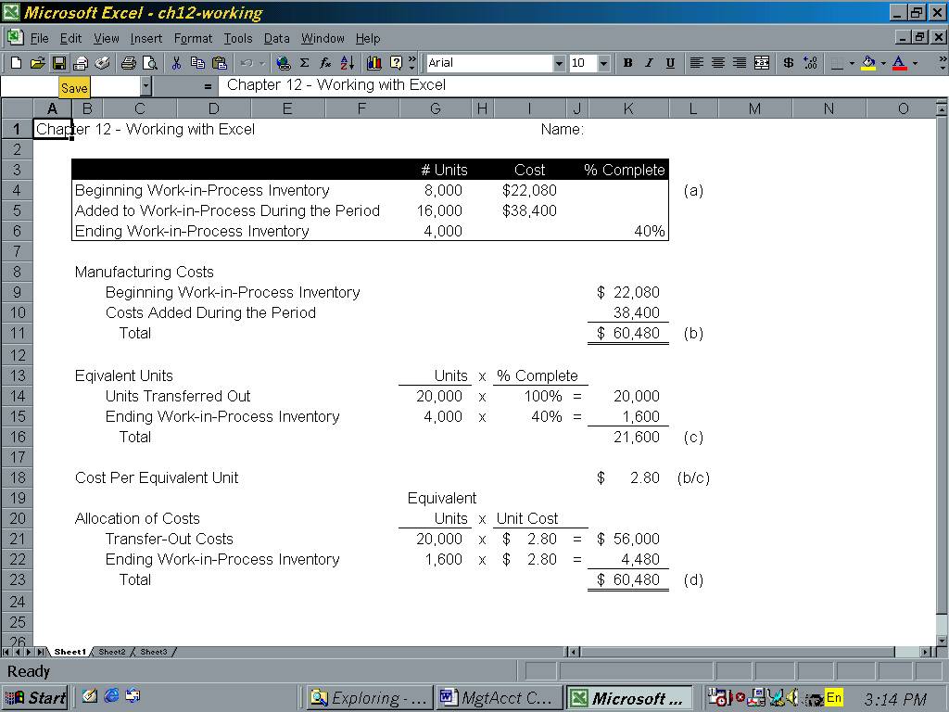
ATC 12-6

Screen capture of cell formulas:

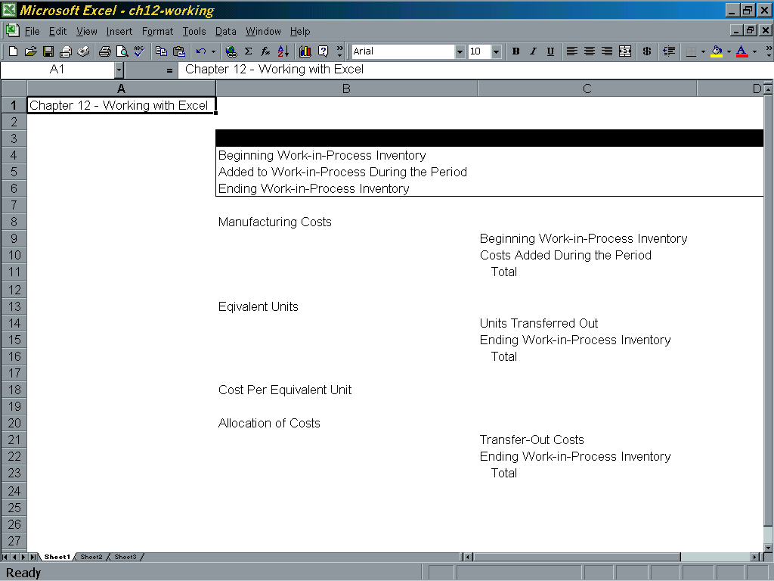

ATC 12-6

Screen capture of cell formulas continued):

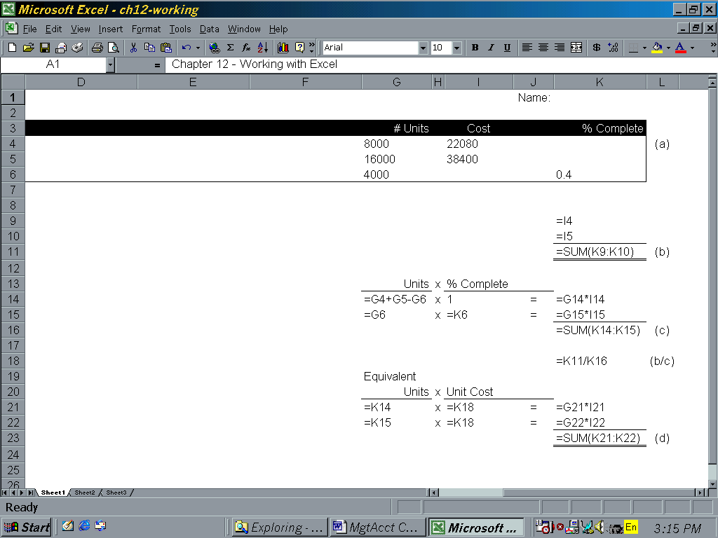

ATC 12-7

Screen capture of cell values:

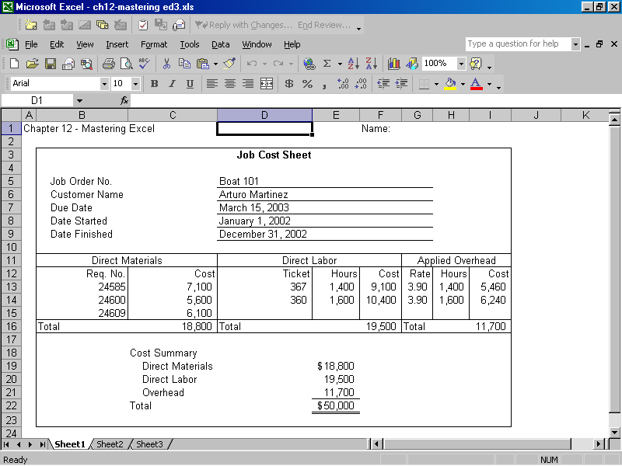
ATC 12-7

Screen capture of cell formulas:

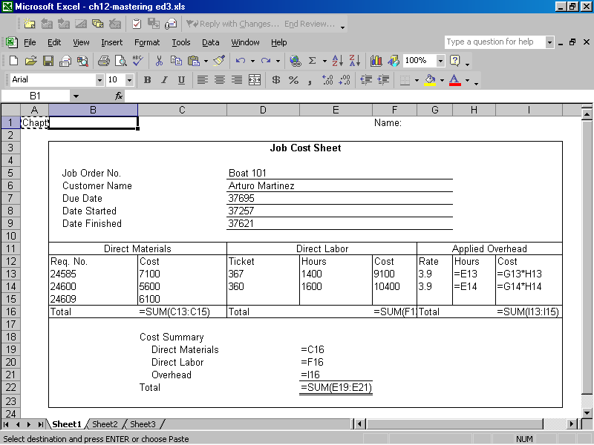

Chapter 12 Comprehensive Problem
 | Equivalent Unit Computations |  |  |  |  |  |  | Equivalent
 |  |  |  |  | Units |  | %  Complete | Units
 | Beginning inventory |  |  |  | 110
 | Units Started |  |  |  | 1,840
 | Total units available for completion |  |  |  | 1,950
 | Units in ending inventory |  |  |  | (90) |  | 60% | 54
 | Units complete |  |  |  | 1,860 |  | 100% | 1,860
 | Total equivalent units |  |  |  |  |  |  | 1,914
 | Cost per Equivalent Unit |  |  |  | Cost |  | / Units = | Cost per unit
 | Beginning inventory |  |  |  | $26,000
 | Raw materials |  |  |  | 62,000
 | Labor |  |  |  | 89,422
 | Overhead |  |  |  | 58,000
 | Total product cost |  |  |  | $235,422 |  | /1,914 = | $123
 | Allocation of Product Cost
 | Cost transferred to finished goods |  |  |  | 1,860 units x $123 = |  |  | $228,780
 | Cost in ending inventory |  |  |  | 54 units x $123 = |  |  | 6,642
 | Total product cost |  |  |  |  |  |  | $235,422

