Answers to Questions

1. Information that is relevant for decision making differs between the alternatives and is future oriented.

2. A variable cost may or may not be relevant. The fact that a cost is variable has no bearing on its relevance. For instance, the cost of direct labor is usually considered a variable cost in the decision as to how many products to produce. But labor costs in another decision context may be irrelevant. For instance, in a decision as to which of two products to produce when labor cost is the same for both, the cost of labor becomes irrelevant (it is now unavoidable). Also, variable costs that are historical in nature would not be relevant.

3. Costs can be classified into the following levels:
(1) Unit-level costs - Costs that are incurred each time a company makes a product or performs a service. These costs can be avoided by eliminating the production of a single unit of product or service.
(2) Batch-level costs - Costs related to the production of more than one product or performance of more than one service that are organized into batches and completed at the same time. Batch-level costs are eliminated when the batch of work is eliminated. When a batch is eliminated, unit-level costs associated with the units in a batch are also eliminated.
(3) Product-level costs - Costs that are incurred to support specific kinds of products or services. Product-level costs are eliminated when the product line is discontinued.
(4) Facility-level costs - Costs that are incurred on behalf of the entire business. These costs are usually totally eliminated when the business is dissolved or they can be partially eliminated when a segment of the business that is in a separate facility is eliminated.

4. Information does not have to be entirely accurate to be relevant for decision making. Knowing that a future cost can be avoided makes the cost relevant even if the exact cost is unknown. Relevance is the predominant characteristic. Precision only enhances relevance. Irrelevant data, no matter how precise, is useless to decision making.

5. The conclusion is invalid because it fails to consider the importance of qualitative data. Factors such as company reputation, employee morale, and customer satisfaction are not quantifiable, but are crucial to the survival of most businesses.

6. The president appears to be overlooking the concept of sunk cost. His company has already incurred a $50,000 loss. The fact that it has not recognized the loss does not mean that the loss has not been incurred. The loss in market value cannot be avoided by borrowing the money for operating activities. The loss (sunk cost) is not relevant and should not be considered. What is important to the decision is whether Carmon today would invest $250,000 by purchasing Mann Stock or would the funds be better invested in operating activities? If the answer is invest in operating activities, then Carmon should sell the Mann stock instead of borrowing the funds.

7. An opportunity cost is the sacrifice of some benefit (revenues, cost savings) that is given up by not choosing an alternative. Opportunity costs are relevant in decisions where the acceptance of one alternative precludes the possibility of accepting other alternatives. Since opportunity costs are future oriented, they are avoidable and relevant for decision making even though the costs are not recorded in financial accounting records. Sunk costs are costs that have been previously recorded in financial accounting records. They are historical in nature and therefore unavoidable and not relevant for decision making.

8. The checking account is not truly free. There is an opportunity cost associated with the account. For example, by leaving a $500 minimum balance in a checking account, the depositor is giving up the opportunity to earn the interest that would accrue if the funds were placed in a savings account.

9. The original costs of the two machines represent sunk costs and should not be considered in the decision regarding which machine to replace. Differential costs are relevant when they apply to future considerations.

10. Some fixed costs are avoidable. For example advertising costs may be fixed regardless of the volume of activity. However, they may be curtailed or eliminated at management’s discretion. Whether a cost is avoidable or not is context sensitive to the decision under consideration.

11. Numerous qualitative characteristics could apply to special order decisions. Two specific considerations are: (1) the effects on regular customers who may learn that they are paying higher prices than those charged on the special order and (2) the capacity effects on profitability. When idle capacity no longer exists, special order customers must be rejected or profitability will suffer. Capacity should not be used to produce special orders that are usually sold at lower prices unless there is idle capacity. The fact that rejection may lead to hard feelings that affect the business’ reputation is also a consideration.

12. The allocated depreciation, warehousing costs, and property taxes will be the same regardless of whether products are produced or purchased. Accordingly, these items would not be relevant to a make-or-buy decision.

13. The two factors that should be considered in allocating shelf space are per unit contribution margin and turnover.

14. The relevant costs are the additional costs that will be incurred as a result of accepting the special order. These are the unit-level costs such as materials, labor, and overhead associated with the special order and the batch-level costs that are necessary to fill the special order batch.

15. It may be possible for a company to purchase a product or service at a price below what it would cost to make the product or provide the service. This could result from differences in wage rates, economies of scale, technological competence and specialization between companies.
16. If the fixed costs that Jane is referring to are avoidable fixed costs, increases in production volume would result in decreases in the avoidable cost per unit to produce the drives. If volume increases enough to reduce the production cost per unit below the cost to outsource, Jane’s point is valid.

17. Qualitative factors that should be considered include: (1) the availability of reliable suppliers that can comply with quality standards and delivery schedules, (2) the possibility of low-ball pricing where the supplier accepts a low price for the outsourced product until the manufacturer becomes dependent and then the supplier raises the price, (3) the internal effects such as employee displacement and the possibility of morale problems with remaining employees which can affect productivity, and (4) the difficulty of reestablishing production capacity if the supplier relationship does not work out.

18. While it may appear from the segment’s reports that it is operating at a loss, this is not necessarily the case. When a segment is eliminated, some of the costs assigned to that segment may still continue. Some of the facility-level costs that have been arbitrarily allocated to the segment may still be incurred after the segment is eliminated. Therefore, these costs should not be considered in an elimination decision. Only the costs that can be avoided by the elimination of the segment are relevant to the decision. If the revenue generated by the segment exceeds avoidable costs, the segment is contributing to the overall profitability of the company and should not be eliminated.

19. Replacing the old machine could result in lower operating income in the first year of the replacement if the old machine is sold at a loss. The loss would affect profitability and may occur when the manager is under significant pressure to maximize profits. The financial benefits of the new machine will not appear in operating reports until the second year of its use, too late for the supervisor that needs immediate results. Under these conditions, the supervisor may sacrifice long-run profitability for short-run rewards.

20. Constraints are caused by resources that are limited. Examples of these business resources include: labor hours, material quantities, shelf space, warehouse space, machine capacity, and machine hours.

Exercise 5-1B

Cost Item | Relevance | Behavior
Cost per product unit | Relevant | Variable
Sales commissions per product unit | Relevant | Variable
Monthly shop rental cost | Irrelevant | Fixed
Monthly advertising cost | Relevant | Fixed

Since rental cost does not differ regardless of which product Mr. Mercer chooses, it is irrelevant.

Exercise 5-2B

Cost Items | Relevance | Behavior
Costs of TV commercials | Irrelevant | Fixed
Labor costs ($3 per unit) | Relevant | Variable
Sales commissions (1% of sales) | Irrelevant | Variable
Sales manager’s salary | Irrelevant | Fixed
Shipping and handling costs ($0.75 per unit) | Irrelevant | Variable
Cost of renting the administrative building | Irrelevant | Fixed
Utility costs for the manufacturing plant | Relevant | Variable
Manufacturing plant manager’s salary | Relevant | Fixed
Materials costs ($4 per unit) | Relevant | Variable
Real estate taxes on the manufacturing plant | Relevant | Fixed
Depreciation on manufacturing equipment | Irrelevant | Fixed
Packaging cost ($1 per unit produced) | Relevant | Variable
Wages of the plant security guard | Relevant | Fixed

All unit-level manufacturing costs (labor, plant utilities, materials, and packaging) are relevant because they could be avoided if Rox purchased the toy planes instead of manufacturing them. Similarly, the product-sustaining and facility-sustaining costs associated with making the planes (the plant manager’s salary and real estate taxes on the plant) are likely avoidable if Rox purchases the planes. In contrast, selling expenses and administrative costs (TV commercials, sales commissions, the sales manager’s salary, shipping and handling costs, and rental of the administrative building) are not avoidable because Rox will continue to incur these costs regardless of whether it makes the planes or buys them from a supplier. Accordingly, these costs are irrelevant to the outsourcing decision. The depreciation on the manufacturing equipment is irrelevant because it is a sunk cost that cannot be avoided because it has already been incurred.

Exercise 5-3B

a.
Fixed Costs | Model 90 | Model 30
Product design cost | $12,000 | $ 7,000
Depreciation on existing machinery | 3,000 | 3,000
Total fixed costs | $15,000 | $10,000

b.
Variable Costs | Model 90 | Model 30
Materials cost per unit | $ 57 | $ 57
Labor cost per unit | 46 | 27
Total variable costs | $103 | $ 84

c.
Avoidable Costs | Model 90 | Model 30
Labor cost per unit | $ 46 | $ 27
Product design cost | $12,000 | $7,000

Exercise 5-4B

Cost Description | Cost Classification
Product design | Product-level cost
Wages of factory janitors | Facility-level cost
Machine setup cost for different production jobs | Batch-level cost
Direct materials | Unit-level cost
Salary of the manager in charge of making a product | Product-level cost
Tires used to assemble a car | Unit-level cost
Payroll cost for assembly-line workers | Unit level cost
Electricity bill of the factory | Facility-level cost

Exercise 5-5B

The $800,000 of facility-sustaining fixed cost is irrelevant because Varela will incur it regardless of whether the special order is accepted or rejected. The differential revenue and avoidable costs are:

Relevant Revenue and Costs
Sales revenue ($32 x 10,000 sets) | $ 320,000
Unit-level costs ($25 x 10,000 sets) | (250,000)
Contribution to profit | $ 70,000

Since differential revenue is greater than avoidable cost, Varela should accept the order.

Exercise 5-6B

Since the product- and facility-level costs do not differ between the alternatives, they are not avoidable. The differential revenue and relevant (avoidable) costs are:

Relevant Revenue and Costs
Sales revenue (1,000 x $300) | $ 300,000
Unit-level materials (1,000 x $150) | (150,000)
Unit-level labor (1,000 x $100) | (100,000)
Unit-level overhead (1,000 x $30) | (30,000)
Contribution to profit | $ 20,000

Since differential revenue exceeds differential costs by $50,000, Sago should accept the special order.

Exercise 5-7B

Sago must consider any potential impact on existing customers. The special order customer should be outside Sago's normal selling territory to avoid demands by current customers for comparable lower prices. If the special order customer serves the same clientele that Sago's existing customers serve, the pricing structure of the retail market could be affected if the special order customer passes on its lower prices to the retail market. Sago must also consider its level of idle capacity. While the company currently appears to have excess capacity, it must retain sufficient capacity to satisfy future increased demand in its regular markets. The company must not devote resources to satisfying the special order market at the expense of satisfying regular, full-pay customers.

Exercise 5-8B

a. Unit-level costs are variable because they increase and decrease in direct proportion to changes in the number of units produced and sold. The variable cost per unit is computed by dividing total unit-level costs by the total number of units ($800,000 ÷ 40,000 units = $20 per unit.) The contribution margin per unit for the special order is –$1 ($19 special order price – $20 variable costs). Since the special order has a negative contribution margin, Gonzalez should reject it.

b. | Incremental revenue ($19 x 7,000 units) | $133,000
 | Variable costs ($20 x 7,000 units) | 140,000
 | Contribution to profit | $ (7,000)

Exercise 5-9B

The allocated facility-level costs are not avoidable because they will be incurred regardless of whether the batteries are made or outsourced. The relevant (avoidable) costs are:

Cost | Per Unit | Total
Materials | $30 | $ 60,000
Labor | 25 | 50,000
Overhead | 5 | 10,000
Total cost | $60 | $120,000

The analysis does not support the president’s conclusion. It would actually cost more to buy the batteries ($75 versus $60) than make them.

Exercise 5-10B

a. The maximum amount that Pierce Corporation would be willing to pay is the amount of production costs that it could avoid if it ceased production. In other words, the cost of buying the wheels must be equal to or less than the avoidable cost of making them. The answer to the question is the per unit avoidable cost of production. The depreciation on the manufacturing equipment cannot be avoided because it is a sunk cost that has already been incurred. Corporate-level facility-sustaining costs will be incurred regardless of whether wheels are purchased or manufactured, so the allocated portion of corporate-level facility-sustaining cost does not differ between the alternatives and is not avoidable. The relevant (avoidable) costs are:

Avoidable Costs for Skateboard Wheels
Materials (60,000 Units x $5) | $300,000
Labor (60,000 Units x $3) | 180,000
Salary of Wheel Production Supervisor | 65,000
Rental Cost of Equipment Used to Make Wheels | 55,000
Total Cost to Make 60,000 Wheels (a) | $600,000
Cost Per Unit ($600,000 ÷ 60,000 Units) | $10

The maximum price that Pierce would be willing to pay for wheels is $10 each.
Exercise 5-10B (continued)

b. The avoidable cost per unit would decrease because the fixed costs (the production supervisor’s salary and rental cost of equipment) would be spread over more units. For 80,000 units, the fixed cost per unit would be $1.50 [($65,000 + $55,000) ÷ 80,000]. The total avoidable cost per unit would be: $1.50 fixed cost + $5.00 materials cost + $3.00 labor cost = $9.50. The higher level of production would reduce the maximum price that Pierce would pay to outsource the wheels.

Exercise 5-11B

a. The facility-level costs are not avoidable because Shipley will incur them regardless of whether the keyboards are produced internally or are outsourced. The relevant (avoidable) costs are:

Item | Cost to Make | Cost to Buy
Cost to purchase 50,000 keyboards |  | $750,000
Unit-level cost of materials and labor | $450,000
Other avoidable manufacturing costs | 400,000
Total avoidable cost | $850,000 | $750,000

If Shipley decides to make the keyboards, its cost will be higher and net income will be lower by $100,000 [$850,000 – ($15 x 50,000 units)]. In other words, it is cheaper to buy the keyboards.

b. Shipley should consider the following qualitative factors. If Shipley makes the keyboards, it will control the production process, including quality control and scheduling. The advantages of vertical integration go beyond attaining the lowest possible price. Accordingly, Shipley may choose to make the keyboards even though it is less expensive to buy them.

Exercise 5-12B

a. Eighty percent of the product-level and all of the facility-level costs are not avoidable. These costs are irrelevant to the decision because Taylor will incur them regardless of whether it makes or buys the doorknobs. The relevant (avoidable) costs are:

Avoidable Costs
Unit-level materials | $ 2,000
Unit-level labor | 2,500
Unit-level overhead costs | 1,600
20% of product-level costs | 800
Total avoidable cost | $6,900

Since the cost of buying doorknobs is $10,000 ($5 x 2,000), Taylor would be better off continuing to make them.

b. Taylor is giving up the opportunity to obtain $5,000 of lease income by continuing to make the doorknobs. This opportunity cost could be avoided by purchasing the doorknobs. When the opportunity cost is included, total avoidable production costs ($6,900 + $5,000 = $11,900) are greater than the purchase cost ($10,000). In this case, Taylor should purchase the doorknobs.

Exercise 5-13B

The original cost and book value of the old boat are irrelevant because they are sunk costs. The relevant costs are:

Decision: | Keep  Old |  | Replace  With New
Cost of the new boat |  |  | $72,000
Additional fuel cost (4 x $12,000) | $48,000 |  | -0-
Opportunity cost | 32,000 |  | -0-
Total cost | $80,000 |  | $72,000

Tidwell should replace the old boat because that would cost less than to continue operating it.

Exercise 5-14B

a. If he keeps his delivery truck, Bob forgoes the opportunity to sell it. Therefore, the opportunity cost of owning and operating the independent business is $15,000.

b. Bob can either continue to operate his independent delivery services, or he can sell the truck, invest the proceeds, and accept work as an instructor. The financial considerations pertaining the two alternatives are:

Decision: | Independent Business |  | Work As Instructor
Opportunity cost | $(15,000)
Cost of investment |  |  | $(15,000)
Business income | 32,000
Investment income ($15,000 x .12) |  |  | 1,800
Instructor salary |  |  | 25,000

The opportunity cost and the cost of the investment are not relevant because they do not differ between the alternatives. The differential revenue is relevant. Since Bob can earn more by offering independent delivery services ($32,000 with the delivery business versus $26,800 as an instructor), the analysis suggests that he should keep the business.

c. From a qualitative perspective, Bob may prefer to sell his truck. The instructor position offers steady work hours and far more leisure time. These factors may be worth the financial sacrifices of Bob’s giving up his own business.

Exercise 5-15B

a. First, identify all revenues and costs associated with operating Segment X. These items appear in the column labeled Segment X. The alternatives are to either keep Segment X or to eliminate it. Ignore the items that do not differ between these alternatives and the sunk costs. The $10,000 of general fixed operating expenses is not avoidable because Willard will incur these costs regardless of whether Segment X is eliminated. The relevant items are:

Relevant Revenue and Costs for Segment X
Revenue | $58,000
Cost of goods sold | (44,000)
Sales commissions | (4,000)
Advertising expense | (6,000)
Effect on income | $4,000

The above analysis indicates the segment contributes to the company's overall profitability by $4,000. Verify this conclusion by preparing comparative company income statements under the two alternatives as shown below:

b.
Decision | Keep Seg. X | Eliminate Seg. X
Sales | $330,000 | $272,000
Cost of Goods Sold | (155,000) | (111,000)
Sales Commissions | (31,000) | (27,000)
Contribution Margin | 144,000 | 134,000
Gen. Fixed Operating Expenses | (30,000) | (30,000)
Advertising Expense | (13,000) | (7,000)
Net Income | $101,000 | $ 97,000

Since Segment X increases the company's profitability by $4,000, it should not be eliminated.

Exercise 5-16B

a. The companywide facility-sustaining costs are not avoidable and therefore not relevant to the elimination decision. The relevant revenue and cost data are summarized below:

Income Statement
Revenue | $750,000
Salaries for Employees | (500,000)
Operating Expenses | (169,000)
Insurance | (37,000)
Division Level Facility-Sustaining Costs | (50,000)
Contribution to Profit | $(6,000)

Since incremental revenue is less than avoidable costs, the segment should be eliminated, thereby increasing companywide income by $6,000.

b. Since total avoidable costs are $756,000, increasing segment revenue to $770,000 would produce a $14,000 contribution to profit ($770,000 – $756,000). Under these circumstances the segment should not be eliminated.

c. To justify its existence, segment revenue must be at least equal to avoidable costs. The Martin Division must generate segment revenue of at least $756,000 to justify its continued operation.

Exercise 5-17B

The facility-level costs are not avoidable because Roberts will incur them even if it eliminates the segment. The original cost and current book value represent different measures of the same sunk cost and are not avoidable. The market value of the building is an opportunity cost that is avoidable. Roberts would avoid the real estate taxes if it sold the building. These and other relevant (avoidable) costs are:

Annual advertising expense | $169,000
Market value of the building (opportunity cost) | 48,000
Annual maintenance costs on equipment | 26,000
Annual real estate taxes on the building | 8,000
Annual supervisory salaries | 72,000
Total | $323,000

Exercise 5-18B

The original cost and book value of the old plant are different measures of the same sunk cost and are therefore not relevant. The opportunity cost of using the old plant in future years is its current market value less its future salvage value ($1,400,000 – $500,000 = $900,000). The new plant would cost $11,000,000 ($12,000,000 – $1,000,000). The relevant (avoidable) costs of operating each plant are:

Decision: | Keep Old Plant |  | Purchase New Plant
Opportunity cost | $ 900,000
Purchase price less salvage |  |  | $11,000,000
Operating costs | 20,000,000 |  | 5,000,000
Total cost | $20,900,000 |  | $16,000,000

Since the cost of the new plant is less than the old, Weldon should replace the old plant. Stated alternatively, by operating the new plant, the cost of the old is avoided. To avoid as much cost as possible, the old plant should be replaced.

Exercise 5-19B

The opportunity cost of using the existing equipment is its market value less the salvage value ($20,000 – $12,000 = $8,000). If Sorenson keeps the old equipment, Sorenson loses the opportunity to sell it and must pay $50,000 to operate it. These costs can be avoided by replacing the old with the new. If Sorenson buys the new equipment, it will initially pay $45,000 but will eventually get back the $10,000 salvage value, so the net cost of the new equipment is $35,000 ($45,000 – $10,000). If Sorenson buys the new equipment, it must pay $10,000 to operate it. The net cost of the new equipment and its operating expenses can be avoided by keeping the old equipment. The avoidable costs are summarized below.

 | Old | New
Opportunity cost less salvage | $ 8,000
Purchase price less salvage |  | $35,000
Operating expenses | 50,000 | 10,000
Total | $58,000 | $45,000

Since the relevant cost of operating the new equipment is lower, Sorenson should replace the old equipment. Stated alternatively, by operating the new equipment, Sorenson can avoid the cost of the old. Since Sorenson wants to avoid as much cost as possible, the old equipment should be replaced.

Exercise 5-20B

If Hulcher continues to operate the old air conditioner, it loses the opportunity to sell it. Therefore, the current market value of the old air conditioner represents an opportunity cost that Hulcher can avoid if it replaces the old model. Similarly, the operating expenses of the old air conditioner can be avoided if Hulcher buys the new air conditioner. The purchase price of the new air conditioner and its operating expenses can be avoided if Hulcher continues to use the old air conditioner. The avoidable costs are summarized below.

Decision: | Keep Old |  | Buy New
Opportunity cost of old machine | $ 27,000
Purchase price |  |  | $80,000
Electricity expense (10 x $30,000) | 300,000
Electricity expense (10 x $20,000) |  |  | 200,000
Total avoidable cost | $327,000 |  | $280,000

Since the costs of operating the new air conditioner are lower, Hulcher should replace the old air conditioner. Stated alternatively, by operating the new air conditioner, Hulcher can avoid the cost of the old. Since Hulcher wants to avoid as much cost as possible, the old air conditioner should be replaced.

Exercise 5-21B

a. The original cost and book value are sunk costs that are irrelevant. The annual opportunity cost computed on a straight-line basis is as follows: $1,000 ÷ 5 years = $200 per year. Since the annual cost of using the riding mower is lower than the annual cost of hiring someone to do the work, Alex should keep the lawn mower and not hire a lawn service.

b. The total cost of hiring a lawn service for a five-year period is $1,750 ($350 x 5). Since the total cost of hiring a lawn service is more than the total opportunity cost ($1,000), Alex should keep the lawn mower and not hire a lawn service. The conclusion is the same as that determined in requirement a because the same data apply to both requirements. The only difference is that requirement a uses an annual analysis and requirement b is based on cumulative totals.

Exercise 5-22B

The decision is whether to make desktop computers or laptop computers. The per unit contribution margins for the products are:

Decision: | Desktop |  | Laptop
Sales price | $1,000 |  | $1,800
Variable costs | 400 |  | 650
Per unit contribution margin | $600 |  | $1,150

While the laptop computers produce a higher contribution margin per unit, Newtech must also consider the quantity it can produce and sell. The total contribution margin for each product is shown below:

Decision | Desktop |  | Laptop
Per unit contribution margin (a) | $ 600 |  | $ 1,150
Units produced and sold (b) | 50,000 |  | 28,000
Total contribution margin (a x b) | $30,000,000 |  | $32,200,000

Based on the total contribution margin, Newtech should produce and sell laptop computers instead of desktop computers.

Problem 5-23B

There are many possible answers for each requirement. The following represents a single example of a correct solution for each part. Students’ answers may differ from the ones supplied here.

a. Assume unit-level labor cost differs between two alternative products. A portion of the labor cost would be avoidable with respect to a decision regarding which of the products should be produced. Alternatively, assume that the labor cost does not differ between the two alternatives. Under these circumstances the labor cost is not avoidable with respect to a decision regarding which of the products should be produced. Since the labor cost is the same for both alternatives, it cannot be avoided regardless of which alternative is selected.

Problem 5-23B (continued)

b. Assume that a company does not have its own shipping facility and personnel such as trucks and drivers. The company would have to pay a third-party carrier a shipping fee based on the weight and size of a given batch of product. Under the circumstances, the shipping cost is avoidable if the batch of product is not produced or shipped. On the other hand, if the company has its own transportation fleet and personnel for shipping, the shipping cost becomes unavoidable because the company needs to pay drivers' salaries and incurs depreciation expense on the trucks regardless of whether a particular batch of product is shipped or not.

c. Suppose the administrative cost is the salary for a store manager. The administrative cost could be avoided if the store were closed. In contrast, assume the administrative cost is the salary of a regional director who is in charge of 10 stores in a region. Under these circumstances, the administrative cost could not be avoided by closing a store in the region.

d. Assume a company is considering whether it should sell a building. The insurance premium paid for the building would be avoidable if a decision were made to sell the building. In contrast, the premium on the building would be unavoidable with respect to a decision regarding whether to lease the building. The company, as the owner, would maintain the insurance protection whether or not it leases the building.

e. Consider a decision regarding the replacement of an old product with a new product. The future amortization on the new product patent could be avoided by a decision to retain the old product. However, the amortization based on the original cost of the old product patent would be unavoidable because it is a sunk cost.

Problem 5-24B

a. With respect to a decision regarding the selection of Order A versus Order B: the differential revenue and the avoidable costs that differ between the alternatives are relevant. The allocated facility-sustaining cost is irrelevant because it is incurred to sustain companywide operations. These facility-sustaining costs will be incurred regardless of which job is accepted and therefore are not avoidable. The fact that more of the companywide overhead cost is allocated to one job than another is irrelevant because the total companywide overhead cost cannot be avoided regardless of how it is allocated between jobs. The supervisor’s salary and the insurance coverage are irrelevant because they do not differ between the alternatives. These costs will be the same regardless of which alternative is accepted. You cannot avoid either cost regardless of which order is accepted. The depreciation on tools cannot be eliminated because they are sunk costs. The relevant information is summarized below:

Cost Category: | Order A | Order B
Contract price | $960,000 | $880,000
Unit-level materials | (360,000) | (316,000)
Unit-level labor | (334,000) | (344,800)
Unit-level overhead | (106,000) | (98,000)
Rental equipment costs | (20,000) | (24,000)
Contribution to profit | $140,000 | $ 97,200

Since Order A provides the higher contribution to profit, it should be accepted.

Problem 5-24B (continued)

b. With respect to a decision regarding the acceptance or rejection of Order B standing alone: changing the decision context changes the items that are considered relevant. While supervisor’s salary and insurance costs cannot be avoided by selecting one order over another, they can be avoided by rejecting both orders. Accordingly, these costs would be relevant to a decision regarding whether to accept or reject Order B standing alone. The relevant information for Order B only is shown below:

Cost Category: | Offer B
Contract price | $880,000
Unit-level materials | (316,000)
Unit-level labor | (344,800)
Unit-level overhead | (98,000)
Rental equipment costs | (24,000)
Supervisor’s salary | (80,000)
Insurance coverage | (54,000)
Contribution to profit | $(36,800)

Since the avoidable costs exceed the differential revenue, Order B should be rejected. This problem illustrates the fact that the avoidable concept is context sensitive. Identifying the appropriate decision is critically important. Order B should never have been compared to Order A because Order B does not provide a contribution to profit. A contribution to profit analysis should be performed before attempting to compare alternative orders.
Problem 5-25B

a. The product-level and facility-level costs are not avoidable because they will be incurred regardless of whether the special order is accepted. The batch-level costs are relevant because they would have to be incurred to accept the special order. Current batches are full. Accordingly, additional items cannot be made without increasing batch-level costs. The relevant (i.e., avoidable) costs for 500 electric drills are:

Production Cost for 500 Electric Drills
Materials cost ($5.00 per unit x 500) | $2,500
Labor cost ($4.00 per unit x 500) | 2,000
Manufacturing supplies ($0.50 x 500) | 250
Batch-level costs (1 batch at $2,000) | 2,000
Total costs | $6,750
Cost per unit = $6,750 ÷ 500 = $13.50

Carroll should reject the special order because the revenue generated from sales to Granado’s Home Maintenance Company (i.e., $12.50 per unit) is below the avoidable cost of production (i.e., $13.50 per unit).

b. Since the batch-level costs are fixed relative to the number of units within the relevant range of 1 to 1,000 units, the avoidable cost per unit will decrease when the number of units increases from 500 to 1,000. The supporting computations are shown below:

Production Cost for 1,000 Electric Drills
Materials cost ($5.00 per unit x 1,000) | $ 5,000
Labor cost ($4.00 per unit x 1,000) | 4,000
Manufacturing supplies ($0.50 x 1,000) | 500
Batch-level costs (1 batch at $2,000) | 2,000
Total costs | $11,500
Cost per unit = $11,500 ÷ 1,000 = $11.50

Problem 5-25B (continued)

Now the avoidable cost per unit is below the revenue per unit (i.e., $11.50) that will be generated by accepting the special order. Accordingly, the special order should be accepted. The decision changes from reject to accept the special order.

c. Carroll Co. must exercise caution to avoid alienating its existing customer base. The fact that a home maintenance company is outside Carroll’s normal marketing channels is a good sign that existing customers will not be affected. However, if the electric drills of this special order are marked with a Carroll label, some association between the two markets may emerge. The association could be positive. A customer may like the electric drill a maintenance specialist uses and want one for himself or herself. In contrast, the relationship could be detrimental. A customer may think that Granado’s buys cheap tools, so Carroll electric drills are cheap. Carroll should consider using a different label for the home maintenance industry versus the retail markets.

Carroll must also consider whether there is adequate productive capacity to service both markets. It would be unwise to turn down existing customers because too many electric drills were shipped to the special order market. Care should be taken to warn the special order customer that repeat business at special prices is not assured. The special order price is dependent on circumstances that can change. Special order customers should not be permitted to think of themselves as regular customers.

Problem 5-26B

a. The unit-level costs of production can be avoided if the fuel additive is purchased. Also, it is reasonable to assume that the cost of the production supervisor’s salary can be avoided if the production process is eliminated. Since Eby will continue to market the product, the selling expenses, product-level advertising cost, and facility-level costs will continue regardless of whether the fuel additive is made or purchased. These items cannot be avoided by purchasing the product. Accordingly, the following items would be relevant to the make-or-outsource decision.

Problem 5-26B (continued)

Avoidable Production Costs for Eby’s Fuel Additive
Unit-level materials costs (100,000 units x $0.80) | $ 80,000
Unit-level labor costs (100,000 units x $0.12) | 12,000
Unit-level overhead costs (100,000 units x $0.38) | 38,000
Fuel additive production supervisor’s salary | 80,000
Total avoidable costs | $210,000

b. The avoidable cost per unit of making the fuel additive is $2.10 per unit (i.e., $210,000 ÷ 100,000 units). Since the price to purchase is only $2.00, Eby can reduce costs by purchasing rather than making the product. Outsourcing the product would increase income by $10,000 [i.e., ($2.10 – $2.00) x 100,000 units].

c. The cost of the supervisor’s salary is fixed relative to the number of units of fuel additive produced and sold. Accordingly, the cost per unit will decline as sales increase. At 160,000 units production cost per unit would be ($288,000 ÷ 160,000 = $1.80). Supporting computations are shown below:

 | Avoidable Costs of Production
 | Unit-level materials costs (160,000 units x $0.80) | $128,000
 | Unit-level labor costs (160,000 units x $0.12) | 19,200
 | Unit-level overhead costs (160,000 units x $0.38) | 60,800
 | Fuel additive production supervisor’s salary | 80,000
 | Total avoidable costs | $288,000

At this level of production the avoidable cost per unit is less to make (i.e., $1.80) than to buy (i.e., $2.00). Eby should continue to make the fuel additive. The decision to outsource should consider the possibility of future growth as well as current production.

Problem 5-26B (continued)

d. Before committing to the outsourcing decision, Eby must consider the ability of the supplier to provide the product in accordance with the company’s quality standards. Also, Eby must assure itself that the product will be delivered on a timely basis. By outsourcing Eby is losing the benefits of vertical integration. The company is dependent on the supplier’s performance. The loss of control must be weighed against the benefits of cost minimization. Eby can protect itself from unreliable suppliers by maintaining a list of certified suppliers. Eby should provide these suppliers with incentives such as quantity purchases and rapid payment of invoices in order to gain preferred customer status.

Problem 5-27B

a. The facility-level costs and 50 percent of the inventory holding costs stay the same regardless of whether Model K is purchased or made. Since these costs do not differ between the alternatives, they are not avoidable.

The depreciation expense is a sunk cost that is not avoidable. However, the $36,000 annual lease option is an opportunity cost that can be avoided if Pleasant stops making the product. The relevant (i.e., avoidable) costs associated with using the existing equipment to make products are shown below:

Annual Avoidable Manufacturing Costs for Model K
Unit-level materials costs (15,000 units x $6) | $ 90,000
Unit-level labor costs (15,000 units x $20) | 300,000
Unit-level overhead costs (15,000 x $8) | 120,000
Opportunity cost of equipment lease | 36,000
Model K production supervisor’s salary | 42,000
Inventory holding costs ($108,000 x .50) | 54,000
Total costs | $642,000

Problem 5-27B (continued)

The avoidable cost per unit is $42.80 (i.e., $642,000 ÷ 15,000 units). Since this amount is higher than the $42 per unit cost to purchase, Pleasant should outsource the product. Outsourcing would decrease cost and increase profitability by $12,000 [i.e., ($42.80 – $42) x 15,000 units).

b. If the old equipment is replaced with the new equipment, the avoidable cost of making Model K versus buying Model K would be as follows:

Avoidable Costs with the Existing Equipment
Unit-level labor costs (15,000 units x $20) | 300,000
Opportunity cost of equipment lease | 36,000
Total costs | $336,000

Avoidable Costs with the New Equipment
Unit-level labor costs (15,000 units x $16*) | 240,000
Depreciation cost on equipment to be purchased** | 30,000
Total costs | $270,000
*$20 x (1 – 20%) = $16
**($200,000 – $80,000) ÷ 4 = $30,000

The avoidable cost with new equipment is lower than that with the existing equipment. If Pleasant replaces the old equipment, the company profit would increase by $66,000 ($336,000 – $270,000). The old equipment should be replaced.

c. If the old equipment will be replaced with the new equipment, the avoidable cost of making, rather than outsourcing, Model K follows:

Problem 5-27B (continued)

Avoidable Manufacturing Costs for Model K
Unit-level materials costs (15,000 units x $6) | $ 90,000
Unit-level labor costs (15,000 units x $16) | 240,000
Unit-level overhead costs (15,000 x $8) | 120,000
Depreciation cost on equipment to be purchased | 30,000
Model K production supervisor’s salary | 42,000
Inventory holding costs ($108,000 x .50) | 54,000
Total costs | $576,000

The avoidable cost per unit of making Model K is $38.40 (i.e., $576,000 ÷ 15,000 units), which is less than the outsourcing cost of $42 per unit. Consequently, the alternative of production with the new equipment will generate $54,000 [($42 – $38.40) x 15,000] more profit than outsourcing. Consequently, the company should produce Model K.

d. Before committing to any outsourcing decision, Pleasant must consider the ability of the supplier to provide the product in accordance with the company’s quality standards. Also, Pleasant must assure itself that the product will be delivered on a timely basis. By outsourcing Pleasant would lose the benefits of vertical integration. The company would be dependent on the supplier’s performance. The loss of control must be weighed against the benefits of cost minimization. Pleasant can protect itself from unreliable suppliers by maintaining a list of certified suppliers. Pleasant should provide these suppliers with incentives for excellent service such as quantity purchases and rapid payment of invoices in order to gain preferred customer status.

Problem 5-28B

a. The rent, utilities, and other general expenses are not relevant because they cannot be avoided by eliminating the department. The revenue and relevant (avoidable) costs are shown below:

Produce
Department
Sales | $440,000
Cost of goods sold | (260,000)
Gross margin | 180,000
Departmental manager’s salary | (35,000)
Contribution to profit | $145,000

Since the Produce Department contributes $145,000 to Chow’s overall profit, the department should not be closed.

b. Income statements before the elimination of the Produce Department

 | Meat  Department |  | Canned Food  Department |  | Produce  Department |  | Company  Total
Sales | $670,000 |  | $600,000 |  | $440,000 |  | $1,710,000
Cost of Goods Sold | (270,000) |  | (330,000) |  | (260,000) |  | (860,000)
Gross Margin | 400,000 |  | 270,000 |  | 180,000 |  | 850,000
Department Manager’s Salary | (42,000) |  | (30,000) |  | (35,000) |  | (107,000)
Rent on Store Lease | (80,000) |  | (80,000) |  | (80,000) |  | (240,000)
Store Utilities | (20,000) |  | (20,000) |  | (20,000) |  | (60,000)
Other General Expenses | (98,000) |  | (98,000) |  | (98,000) |  | (294,000)
Net Income (Loss) | $160,000 |  | $ 42,000 |  | $ (53,000) |  | $ 149,000

Problem 5-28B (continued)

Income statements after the elimination of the Produce Department:

 | Meat  Department |  | Canned Food  Department |  | Company  Total
Sales | $670,000 |  | $600,000 |  | $1,270,000
Cost of Goods Sold | (270,000) |  | (330,000) |  | (600,000)
Gross Margin | 400,000 |  | 270,000 |  | 670,000
Departmental  Manager’s Salary | (42,000) |  | (30,000) |  | (72,000)
Rent on Store Lease | (120,000) |  | (120,000) |  | (240,000)
Store Utilities | (30,000) |  | (30,000) |  | (60,000)
Other General Expenses | (147,000) |  | (147,000) |  | (294,000)
Net Income (Loss) | $ 61,000 |  | $ (57,000) |  | $ 4,000

The elimination of the Produce Department results in a reduction of the company’s total income in the amount of $145,000 ($149,000 – $4,000). This result confirms the conclusion reached in requirement a.

c. By operating the Produce Department, the company loses the opportunity to earn $160,000. Accordingly, the $160,000 is an opportunity cost of the Produce Department. Considering the opportunity cost, the total avoidable cost of operating the Produce Department is greater than the revenue it generates (see computations above). Under the circumstances, the Produce Department should be eliminated.

Problem 5-29B

a.
 | Division Z
Sales | $1,710,000
Unit-level manufacturing costs | (900,000)
Rent on manufacturing facility | (450,000)
Unit-level selling and admin. expenses | (150,000)
Division-level fixed selling and admin. exp. | (240,000)
Contribution to profit | $ (30,000)

Since Division Z’s contribution to profit is negative, the division should be eliminated. This conclusion is supported by the following companywide income statements.

Companywide Income Statements If: | Keep  Division Z | Eliminate  Division Z
Sales | $5,310,000 | $3,600,000

Less: cost of goods sold
Unit-level manufacturing costs | (2,580,000) | (1,680,000)
Rent on manufacturing facility | (910,000) | (460,000)
Gross margin | 1,820,000 | 1,460,000
Less: operating expenses
Unit-level selling and admin. expenses | (255,000) | (105,000)
Division-level fixed selling and admin. exp. | (505,000) | (265,000)
Headquarters facility-level costs | (240,000) | (240,000)
Net income (loss) | $ 820,000 | $ 850,000

b. Begin by determining the sales price per unit and the cost per unit for the costs that will vary relative to the number of units made and sold. Divide the total cost for each category by 30,000 units to get cost per unit. Headquarters facility-level costs are omitted from the analysis because these costs are not avoidable.

Problem 5-29B (continued)

 | Division Z | ÷ No. Units | Per Unit Amounts
Sales | $1,710,000 | ÷ 30,000 | $57.00
Unit-level manufacturing costs | (900,000) | ÷ 30,000 | 30.00
Rent on manufacturing facility | (450,000) | Fixed
Unit-level selling and admin. expenses | (150,000) | ÷ 30,000 | 5.00
Division-level fixed selling and admin. exp. | (240,000) | Fixed

Next, compare differential revenues with avoidable cost.

 | Division Z
Sales revenue (45,000 units x $57) | $2,565,000
Avoidable costs:
Unit-Level manufacturing costs (45,000 units x $30) | (1,350,000)
Rent on manufacturing facility | (450,000)
Unit-level selling and admin. Exp. (45,000 units x $5.00) | (225,000)
Division-level fixed selling and admin. exp. | (240,000)
Contribution to profit | $ 300,000

Since Division Z would provide a positive contribution to profit at 45,000 units, the division should not be eliminated. As this problem suggests, it is important to consider growth potential before deciding to eliminate a segment.

c. Given that Gilder is paying $450,000 to lease the manufacturing facility for Division Z, the company could earn $460,000 by subleasing the manufacturing facility (i.e., $910,000 – $450,000). By operating the division, the company is giving up the opportunity to sublease the facility. This is an opportunity cost that would be avoidable by eliminating Division Z. Accordingly, it must be included in the analysis. At a volume of 45,000 units Division Z contributes only $300,000 to profitability. When the opportunity cost is considered, the profit becomes a loss (i.e., $300,000 profit – $460,000 opportunity cost = $160,000 loss). Under these circumstances, Division Z should be eliminated.

Problem 5-30B

a. Since Heth doesn’t have to pay sales commissions in this situation, the company should remove that item from consideration. The advertising, salary of production supervisor, and facility-level expenses are not relevant because they will be incurred regardless of whether the special order is accepted or rejected. In other words, they do not differ between the alternatives. The differential revenue and relevant (i.e., avoidable) costs are shown below:

Revenue (30,000 units x $26.50) | $795,000
Variable costs
Materials cost (30,000 x $15) | (450,000)
Labor cost (30,000 x $8) | (240,000)
Manufacturing overhead (30,000 x $1.50) | (45,000)
Shipping and handling (30,000 x $0.50) | (15,000)
Contribution margin | $ 45,000

Since the differential revenue is greater than the avoidable costs, the special order should be accepted.

b. The revenue, shipping and handling, sales commissions, advertising costs, and general company expenses must be eliminated from consideration because they do not differ between the alternatives. The relevant information is as follows:

 | Make |  | Buy
Unit-level costs
Purchase price (60,000 x $26) |  |  | $1,560,000
Materials cost (60,000 x $15) | $ 900,000 |  | 0
Labor cost (60,000 x $8) | 480,000 |  | 0
Manufacturing overhead (60,000 x $1.50) | 90,000 |  | 0
Fixed expenses
Salary of production supervisor | 126,000 |  | 0
Impact on profitability (total cost) | $1,596,000 |  | $1,560,000

At 30,000 units, Heth should buy the radio/cassette players.

Problem 5-30B (continued)

Relevant data at 140,000 units of product:

 | Make | Buy

Unit-level costs
Purchase price (140,000 x $26) |  | $3,640,000
Materials cost (140,000 x $15) | $2,100,000 | 0
Labor cost (140,000 x $8) | 1,120,000 | 0
Manufacturing overhead (140,000 x $1.50) | 210,000 | 0

Fixed expenses
Salary of production supervisor | 126,000 | 0
Impact on profitability | $3,556,000 | $3,640,000

At a volume of 140,000 units, it is cheaper to make the units than to buy them. This result occurs because the fixed cost (i.e., production supervisor’s salary) is spread over a larger number of units, thereby reducing the average cost per unit.

c. The companywide facility-level expenses are not relevant because they do not differ between the alternatives (i.e., operate or eliminate the segment). The differential revenue and avoidable costs are shown below:

Revenue (60,000 units x $30) | $1,800,000
Variable costs
Materials cost (60,000 x $15) | (900,000)
Labor cost (60,000 x $8) | (480,000)
Manufacturing overhead (60,000 x $1.50) | (90,000)
Shipping and handling (60,000 x $0.50) | (30,000)
Sales commissions (60,000 x $2) | (120,000)
Contribution margin | 180,000
Fixed expenses
Advertising costs | (30,000)
Salary of production supervisor | (126,000)
Impact on profitability | $ 24,000

Problem 5-30B (continued)

The analysis shows that the production and sale of radio/cassette players is contributing $24,000 toward the profitability of the enterprise. The current net loss that appears on the income statement results from companywide facility-level expenses that would continue regardless of whether the segment is eliminated. Accordingly, Heth should continue to operate the segment.

Problem 5-31B

The decision is whether to make Product M or Product N. The per unit contribution margins for the products are shown below:

Decision | Product M |  | Product N
Revenue | $75 |  | $90
Variable cost | 48 |  | 55
Contribution margin | $27 |  | $35

a. While Product N produces a higher contribution margin per unit, consideration must also be given to the labor that it takes to produce each product. This can be accomplished by determining the contribution margin per labor hour. The appropriate computations are shown below:

Decision | Product M |  | Product N
Contribution margin (a) | $27 |  | $35
Labor hours to produce (b) | 3 |  | 5
Contribution margin per labor hour (a÷b) | $ 9 |  | $ 7

Based on the contribution margin per labor hour, Product M should be produced.

b. Since the company can only stock one product because of limited floor space, the product that produces the higher total contribution margin should be chosen. Clearly, Product N has the higher per unit contribution margin, but the company can sell more units of Product M. Which is better, fewer sales of high-profit items or higher sales of low profit items?

Problem 5-31B (continued)

To determine the answer multiply the contribution margin per unit by the number of units sold. The solution is shown below:

Decision | Product M |  | Product N
Contribution margin (a) | $ 27 |  | $ 35
Units produced and sold (b) | 8,000 |  | 7,000
Total contribution margin (a x b) | $216,000 |  | $245,000

In this case Product N has the higher per unit contribution margin and the higher total contribution margin. Accordingly Product N should be sold.

c. While Product N has the higher contribution margin per unit, consideration must be given to the machine hours required to produce the products. This can be accomplished by computing the contribution margin per machine hour. The appropriate computations are shown below:

Decision | Product M |  | Product N
Contribution margin (a) | $27 |  | $35
Machine hours to produce (b) | 6 |  | 10
Total cont. margin per machine hr. (a ÷ b) | $ 4.50 |  | $ 3.50

Based on the contribution margin per machine hour, Product M should be produced. Given that the company has a maximum capacity of 36,000 machine hours and can sell all the products it produces, Product M will increase profits by $162,000 (i.e., $4.50 x 36,000 hours) where Product N can only increase profits by $126,000 (i.e., $3.50 x 36,000 hours).

Product N produces the greater profit per unit but profitability is dependent on the number of machine hours involved in producing the product. Product M produces a higher profit per machine hour because it takes fewer machine hours per unit to produce. Therefore Product M should be produced.

Problem 5-32B

a. The historical cost of the old machine is a sunk cost and therefore is not relevant. The relevant (i.e., avoidable) costs for each alternative are shown below:

Decision | Keep  Old |  | Replace  With New
Opportunity cost of old | $100,000
Purchase price of the new machine |  |  | $180,000
Operating expense¹ | 480,000 |  | 336,000
Total avoidable cost | $580,000 |  | $516,000
¹Operating expense of old $120,000 x 4 years = $480,000.
Operating expense of new $480,000 x .70 = $336,000.

The analysis suggests that the old machine should be replaced because Doyle would minimize avoidable cost with this decision. The company would earn an additional $64,000 (i.e., $580,000 – $516,000 = $64,000 cost savings).

b. |  | 2008 | 2009 | 2010 | 2011 | Total
 | Revenue | $320,000 | $320,000 | $320,000 | $320,000 | $1,280,000
 | Depreciation Exp. | (40,000) | (40,000) | (40,000) | (40,000) | (160,000)
 | Operating Exp. | (120,000) | (120,000) | (120,000) | (120,000) | (480,000)
 | Net Income | $160,000 | $160,000 | $160,000 | $160,000 | $ 640,000

c. |  | 2008 | 2009 | 2010 | 2011 | Total
 | Revenue | $320,000 | $320,000 | $320,000 | $320,000 | $1,280,000
 | Depreciation Exp. | (45,000) | (45,000) | (45,000) | (45,000) | (180,000)
 | Operating Exp. | (84,000) | (84,000) | (84,000) | (84,000) | (336,000)
 | Loss on Disposal* | (60,000) |  |  |  | (60,000)
 | Net Income | $131,000 | $191,000 | $191,000 | $191,000 | $704,000

*$100,000 Market Value – $160,000 Book Value = $60,000 Loss

Problem 5-32B (continued)

d. The computations shown in requirements b and c support the avoidable cost analysis in part a. The company will earn $64,000 (i.e., $704,000 – $640,000) more over the four year period by replacing the machine. However, the loss on disposal causes net income in 2008 to be lower when the machine is replaced. The benefit of replacement is reflected in the financial statements in years 2009 through 2011. Managers under pressure to demonstrate higher immediate performance may choose short-term higher reported results over long-run higher economic benefits. Under these circumstances, the manager would choose to retain the old machine even though the long-term profitability is better if the machine is replaced. It is the responsibility of upper-level management to devise motivational systems that encourage employees to act in the best interest of their companies.

ATC 5-1

a. Unit-level, batch-level, and product-level costs can be avoided when a product line is eliminated. In order to avoid these costs Mazda will sacrifice the revenue that was generated through sales of the product line. Mazda will also give up product diversity which may have lured customers to the Mazda line. Wallace’s decision to eliminate product lines suggests that the incremental revenue generated by sales of the product line was less than the avoidable cost.

b.

Annual Costs of Operating Each Sales Channel | Channel 1 | Channel 2 | Channel 3 | Total
Unit-Level Selling Costs
Selling Supplies Cost | $ 40,000 | $ 32,000 | $ 22,000 | $ 94,000
Sales Commissions | 425,000 | 355,000 | 225,000 | 1,005,000
Shipping and Handling | 49,000 | 40,000 | 24,000 | 113,000
Miscellaneous | 29,000 | 20,000 | 17,000 | 66,000
Total Unit-Level |  |  |  | 1,278,000
Facility-Level Selling Costs
Rent | 240,000 | 245,000 | 236,000 | 721,000
Utilities | 50,000 | 40,000 | 48,000 | 138,000
Staff Salaries | 1,088,000 | 900,000 | 855,000 | 2,843,000
Supervisory Salaries | 170,000 | 150,000 | 100,000 | 420,000
Depreciation on Equipment | 303,000 | 300,000 | 307,000 | 910,000
Allocated Companywide Facility-level Expenses | 100,000 | 100,000 | 100,000 | 300,000
Total Facility-Level Costs |  |  |  | $5,332,000

1. Since 80% of the sales will be transferred to other channels, only 20% of the unit-level sales costs will be saved. Accordingly, $255,600 ($1,278,000 x .20) unit-level costs are avoidable.

ATC 5-1 (continued)

2. Sixty percent of the sales staff salaries are avoidable resulting in savings of $1,705,800 (i.e., $2,843,000 x .6).

3. The supervisory salaries for Channels 2 and 3 are avoidable resulting in a savings of $250,000 (i.e., $150,000 + $100,000).

4. Although the annual depreciation cost would be considered a sunk costs, there is an opportunity cost associated with disposal of the equipment, which results in a savings of $50,000 per year [$650,000 (current selling price) − $450,000 (future selling price) ÷ 4 = $50,000.] For the purpose of this example, these savings will be added to avoidable costs.

5. Since the channel offices are closed the total amount of rent and utilities costs are avoidable resulting in a savings of $721,000 and $138,000, respectively.

6. Allocated companywide facility-level expenses are not avoidable. They will be distributed to the other sales channels.

Total avoidable annual costs total $3,120,400 (i.e., $255,600 + $1,705,800 + $250,000 + $50,000+ $721,000 + $138,000).

c. Inventory holding costs include: warehouse space; warehouse staff; record keeping; lost, damaged, or stolen merchandise; and financing (i.e., interest). When inventory is reduced, a portion of these costs can be avoided.

d. Many possible answers exist for this requirement. The instructor should evaluate student responses on the basis of logic and reasoning ability. One area in which Mazda has focused attention is that of product development. The company started production of a sports utility vehicle and has developed a new car that includes many of the features demanded by today’s customers.

ATC 5-2

a. Task 1 The fixed costs are not relevant because they will remain the same regardless of whether the special order is accepted. The total unit-level incremental costs that will be incurred if the special order is accepted are $592 (i.e., product materials $60, installation $200, manufacturing overhead $2, shipping and handling $25, sales commissions $300, non-manufacturing miscellaneous $5). Since the per unit incremental cost of $592 is below the incremental revenue of $800 per unit, the special order should be accepted.

Task 2 The costs that could be avoided if the manufacturing process were to be outsourced are the following:

Unit-level variable costs
Product materials cost (12,000 x $60) | $ (720,000)
Manufacturing overhead (12,000 x $2) | (24,000)
Fixed expenses
Research and development | (2,700,000)
Legal fees to assure product protection | (780,000)
Rental cost of manufacturing facility | (600,000)
Other manufacturing cost (i.e., salaries, utilities, etc.) | (744,000)
Avoidable cost | $(5,568,000)

The total avoidable cost per unit would be $464 (i.e., $5,568,000 / 12,000 units). Since the avoidable cost is below the price required to purchase (i.e., $600), Maccoa would be better off to continue to produce the software.

Task 3 If the division were eliminated, all costs except the allocated companywide facility-level cost and the depreciation on production equipment (sunk cost) could be avoided. The revenue would also be lost. The difference between the lost revenue and the avoidable cost is shown below:

ATC 5-2 (continued)

Revenue (12,000 units x $1,200) | $14,400,000

Unit-level variable costs
Product materials cost (12,000 x $60) | (720,000)
Installation labor cost (12,000 x $200) | (2,400,000)
Manufacturing overhead (12,000 x $2) | (24,000)
Shipping and handling (12,000 x $25) | (300,000)
Sales commissions (12,000 x $300) | (3,600,000)
Non-manufacturing miscellaneous Costs (12,000 x $5) | (60,000)
Contribution margin (12,000 x $608) | 7,296,000

Fixed expenses
Research and development | (2,700,000)
Legal Fees to assure product protection | (780,000)
Advertising costs | (1,200,000)
Rental cost of manufacturing facility | (600,000)
Other manufacturing cost (i.e., salaries, utilities, etc.) | (744,000)
Division-level facility sustaining expenses | (1,730,000)
Net income (loss) | $ (458,000)

Since the avoidable cost exceeds the incremental revenue, the division should be eliminated.

The sale of an additional 1,000 units would increase total sales to 13,000 units. The difference between the lost revenue and the avoidable cost at a sales level of 13,000 units is shown below:

ATC 5-2 (continued)

Revenue (13,000 units x $1,200) | $15,600,000
Unit-level variable costs
Product materials cost (13,000 x $60) | (780,000)
Installation labor cost (13,000 x $200) | (2,600,000)
Manufacturing overhead (13,000 x $2) | (26,000)
Shipping and handling (13,000 x $25) | (325,000)
Sales commissions (13,000 x $300) | (3,900,000)
Non-manufacturing miscellaneous costs (13,000 x $5) | (65,000)
Contribution margin (13,000 x $608) | 7,904,000
Fixed expenses
Research and development | (2,700,000)
Legal Fees to assure product protection | (780,000)
Advertising costs | (1,200,000)
Rental cost of manufacturing facility | (600,000)
Other manufacturing cost (i.e., salaries, utilities, etc.) | (744,000)
Division-level facility sustaining expenses | (1,730,000)
Net income | $150,000

At a sales level of 13,000 units, the division should not be eliminated.

b.
(1) All variable costs are not always relevant. For example, assume that the special order customer approaches management directly, thereby eliminating the need to pay sales commissions. Under these circumstances the sales commissions would not be relevant to a decision regarding whether the special order should be accepted. Variable costs can be either relevant or not relevant depending on the particular circumstances associated with the special decision.
ATC 5-2 (continued)

(2) Research and development costs are relevant because they are not incurred if the product is outsourced. Advertising costs are not relevant because they are necessary to promote the product regardless of whether it is manufactured or outsourced. To be relevant, costs must differ between the alternatives and be future oriented.
(3) Increases in volume cause the total contribution margin to increase. Accordingly, more margin is available to cover fixed cost or to contribute to profitability.

ATC 5-3

a. The relevant costs of switching from a manual system to a FRM system include:
- the cost of the system itself (software, etc.)
- the cost savings resulting from collecting one’s cash more quickly (i.e., the time-value of money)
- the cost savings from processing invoices electronically versus manually (the article suggest $2.50 per invoice versus $5.00)
- if used for accounts payable, the additional discounts that may be realized by making more payments within the discount period.
- The cost savings that result from reducing the amount of staff time wasted tracking the status of paper invoices, etc.

b. This is an opportunity cost. By not having money in the bank, due to the slower collection time that a manual system causes, companies are losing interest revenue or incurring greater interest cost.

c. According to the author, the biggest challenge facing a company trying to switch to an internet based FRM system is “… changing the behavior of humans who have always made and trusted paper transactions.”

ATC 5-4

Each memo will be different. The instructor should evaluate responses on the basis of logic. Some representative arguments for each requirement are listed below as examples.

a. It is the incompetence of the state that causes the full cost of providing collection services to be higher than the price offered by private companies. Indeed, private companies have to cover their full cost. Why should the State Revenue Department not have the same requirement?

b. The Revenue Department is required to incur costs on behalf of the state. These costs have nothing to do with the collection of municipal taxes and should not be included. Private companies are at liberty to accept special orders on the basis of relevant cost. Why should the State Revenue Department not have the same opportunity?

c. The issue will probably be resolved in court by a jury of non-accountants.

ATC 5-5

a. The amount of loss would be $35,000 (i.e., $110,000 − $75,000).

b. The $110,000 purchase price is a sunk cost. The current market price of $75,000 is an opportunity cost associated with holding the original site. It is a relevant opportunity cost because it can be avoided if the land purchased is sold.

c. Mr. Dillworth’s conclusion is not supported by quantitative analysis. The opportunity cost of holding on to the old site is $75,000 while the cost of acquiring the new lot is $80,000. Accordingly, it is cheaper to hold on to the existing lot. However, the information in the problem suggests that there is a qualitative feature that justifies the purchase of the new lot even though it is more expensive. Specifically, the traffic count for the new site is twice that of the old site. More traffic means more customers. This suggests that the new site is worth the extra cost.

d. While interpretations may vary, there are at least three standards that could be considered to be violated by Mr. Dillworth’s refusal to disclose the alternative site purchase option. These include: (1) the integrity standard to refrain from either actively or passively subverting the attainment of the organization’s legitimate and ethical objectives, (2) the objectivity standard to communicate information fairly and objectively, and (3) the objectivity standard to disclose fully all relevant information that could reasonably be expected to influence an intended user’s understanding of the reports, comments, and recommendations presented.

e. Dillworth has a reason to keep the bad decision secret (i.e., he will suffer a reprimand if the matter comes to light). He has the opportunity (i.e., he is the only person to know of the better deal). Finally, he has the means for rationalization (i.e., how can he be expected to live up to standards that his boss fails to attain?). Accordingly, the situation contains all of the elements identified by Cressey as harbingers of unethical conduct.

f. Dillworth’s behavior is not subject to criminal penalties under the Sarbanes-Oxley Act because an error in judgment is not a crime.

ATC 5-6

Screen capture of cell values:

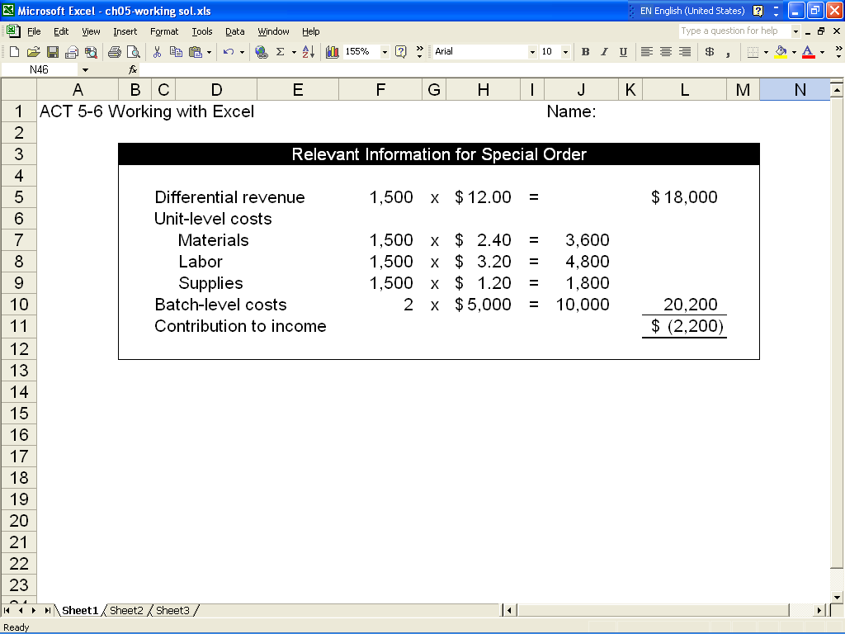

ATC 5-6 (continued)

Screen capture of cell formulas:

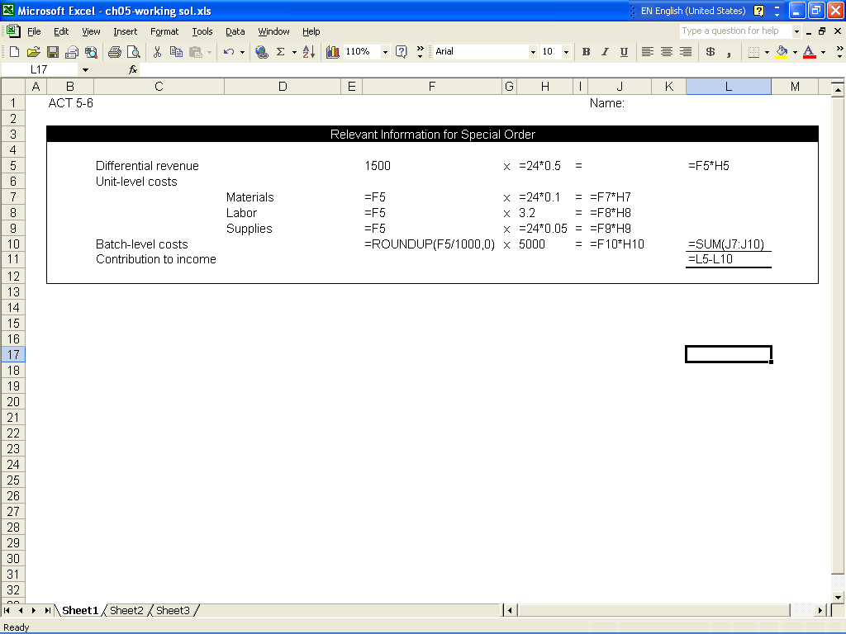

ATC 5-7

Screen capture of cell values:

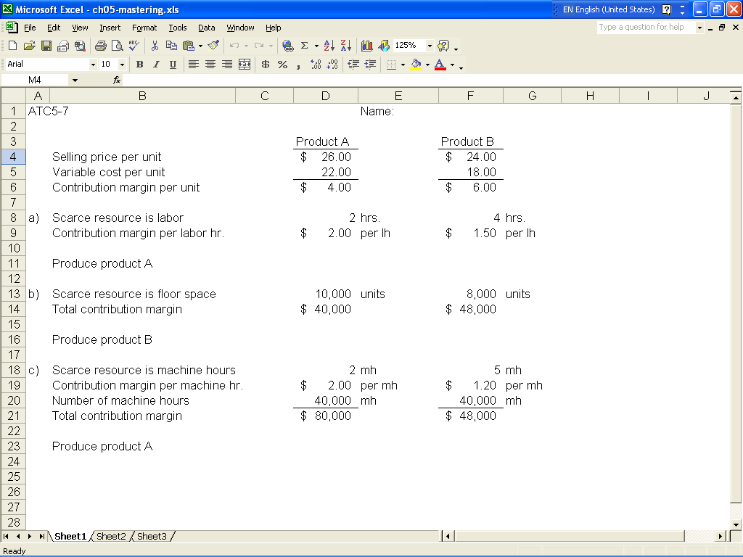

ATC 5-7 (continued)

Screen capture of cell formulas:

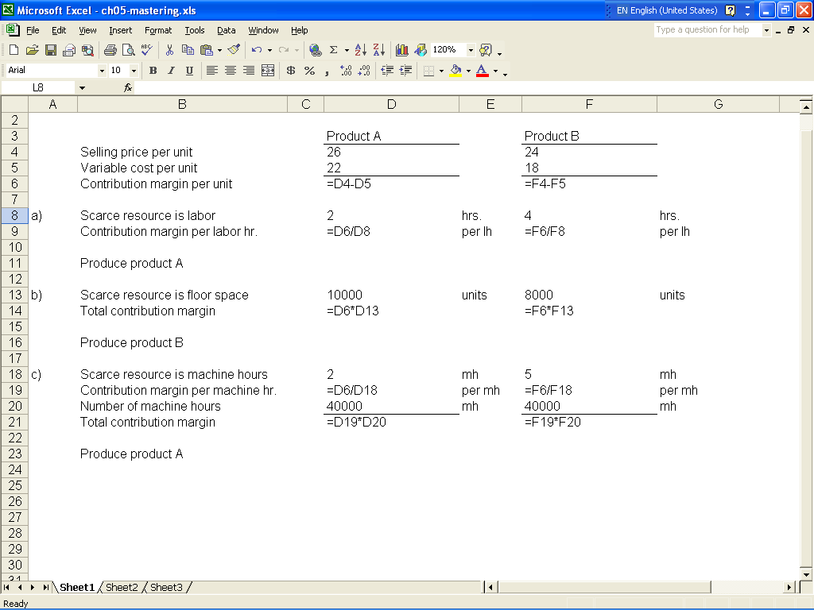

Chapter 5 Comprehensive Problem

Requirement a

The relevant costs include the following

 |  |  |  | Per Unit
 | Direct materials |  |  | $40
 | Direct labor |  |  | 25
 | Production supplies |  |  | 4
 | Sales commission |  |  | 6
 | Total relevant cost |  |  | $75

All other costs are irrelevant because they remain the same regardless of whether the special
offer is accepted or rejected. Since the relevant cost (i.e., $75) is higher than the special offer price (i.e., $72), the offer should be rejected.

Requirement b
 | The relevant cost include the following
 |  |  |  |  |  | Per Unit
 | Direct materials |  |  |  |  | $40
 | Direct labor |  |  |  |  | 25
 | Production supplies |  |  |  |  | 4
 | Rent on manufacturing facility
 | ($50,000 / 5,000 units) |  |  |  |  | 10
 | Total relevant cost |  |  |  |  | $79

Since the relevant cost of making the modems (i.e., $79) exceeds the cost of buying them (i.e., $76), Magnificent should outsource the modems.

Requirement c

The relevant cost include the following: (Note that the fixed cost per unit for the manufacturing rent decreases as a result of the increase in the number of units produced.)

Since the relevant cost of making the modems (i.e., $74) is below the cost of buying them (i.e.,
$76), Magnificent should make the modems.

 |  |  |  | Per Unit
 | Direct materials |  |  | $40
 | Direct labor |  |  | 25
 | Production supplies |  |  | 4
 | Rent on manufacturing facility  ($50,000 / 10,000 units) |  |  | 5
 | Total relevant cost |  |  | $74

