Answers to Questions

1. Break-even is the point where total revenue is equal to total costs. It can be measured in units or sales dollars.

2. In the contribution margin income statement all variable costs are subtracted from sales revenues to determine the contribution margin before subtracting all fixed costs to derive profit. The traditional statement does not disclose contribution margin because cost of goods sold and operating expenses consist of both variable and fixed costs.

3. The contribution margin can be used to determine break-even for the number of units (volume) needed to be produced and sold or the total amount of sales dollars needed to be earned. The concept can also be used to determine the production and sales volume or sales dollars necessary to attain a target profit. Finally, the contribution margin can be used to measure the effects on profitability of changes in sales price, sales volume, cost of sales, or simultaneous changes among these variables.

4. The margin of safety is the decrease in sales that can occur before experiencing a loss. The margin of safety expressed as a percentage would mean Company A’s actual sales could decline by only 22% below budgeted sales before the company reaches break-even and a greater decline would result in a loss. Company B sales would have to decline by more than 52% below budgeted sales to experience a loss. Accordingly, Company A is at greater risk of a loss when sales are less than budgeted.

5. The variables that affect profitability are sales price, volume, variable costs, and fixed costs. Two techniques for analyzing the relationships among these variables in order to estimate profitability are sensitivity analysis, performed by spreadsheet software that executes what if statements, and the contribution margin approach.

6. Customers are often willing to pay a premium price for a product that incorporates a new technology they would like to be the first to use, especially when there has been widespread advertising of the product. Products that carry a prestigious brand name are also likely to sell at a premium. Prestige pricing would be an appropriate pricing strategy for such products. Prestige pricing is pricing the product at a greater than average mark-up with the expectation that the increased demand will motivate customers to pay higher than average prices. Other examples are possible.

7. Three approaches for determining break-even are as follows:

- The per unit contribution margin approach which shows break-even in units.
- The contribution margin ratio approach which shows break-even in sales dollars.
- The equation method which shows break-even in units.

8. The algebraic equation method for determining break-even is stated as follows:

Selling price per unit Variable cost per unit
x = x +Fixed cost
No. of units sold No. of units sold

The results of this method do not differ from the per unit contribution margin approach. Both determine break-even in units produced and sold.

9. The break-even point can be affected by the relative quantities (sales mix) of the products sold.

10. CVP analysis assumes a strictly linear relationship between the variables, constant worker efficiency within the relevant range, and a constant level of inventory where production equals sales. To the extent these assumptions are invalid, CVP analysis will be inaccurate. Estimates are used frequently in business decision making. Actual data is not available until after the fact so managers most often have to rely on projections that by their nature are estimates.

11. From Hartwell’s perspective, the $2,000 cost of the computer is a fixed cost. The computer costs $2,000 with or without Jamail’s contribution. Accordingly, whatever Jamail is willing to contribute toward the purchase will contribute to the coverage of the fixed cost. Jamail’s $750 offer should be accepted.

12. Break-even:
(Sales price x Units) = (Variable cost x Units) + Fixed cost

Target profit considered:
(Sales price x Units) = (Variable cost x Units) + Fixed cost +
Desired profit

13. The cost-volume-profit formulas provide only quantitative data. For example, they do not account for factors such as competitive forces and consumer demand. Cost-volume-profit formulas provide only one source of data in a complicated price-setting decision.

14. Cost-volume-profit analysis is based on a set of assumptions that are normally invalid at extreme levels of production. For example, even the fixed cost for plant and equipment will not remain constant if production is raised above some level. However, most companies do not operate at the extremes. Instead, they have a narrow range of activity over which they usually operate. This range is called the relevant range. Fortunately, most of the assumptions used in cost-volume-profit analysis are valid over the relevant range of activity.

Exercise 3-1B

Break-even in units = Fixed cost ÷ Contribution margin
Break-even in units = $75,000 ÷ ($9.00 – $6.00)
Break-even in units = 25,000 units
Break-even in dollars = $9.00 x 25,000 units = $225,000

Exercise 3-2B

X = Number of units
(Price x units) = Fixed cost + (Variable cost per unit x Units)
$29X = $450,000 + $20X
$9X = $450,000
X = 50,000 units
Break-even in dollars = $29 x 50,000 units = $1,450,000

Exercise 3-3B

Contribution margin = Sales – Variable cost = $20 – $12 = $8
Contribution margin ratio = Contribution margin ÷ Sales
Contribution margin ratio = $8 ÷ $20 = 40%

Sales in dollars = (Fixed cost + Desired profit) ÷ Contribution margin ratio
Sales in dollars = ($140,000 + $40,000) ÷ .40
Sales in dollars = $450,000
Sales in units = $450,000 ÷ $20 = 22,500 units

Exercise 3-4B

Y = Number of units
(Price x Units) = Fixed cost + (Variable cost per unit x Units) + Profit
$71Y = $390,000 + $50Y + $240,000
$21Y = $630,000
Y = 30,000 units
Sales in dollars = $71 x 30,000 units = $2,130,000

Exercise 3-5B

Sales revenue | $480,000
− Contribution margin | 80,000
= Variable cost | 400,000
÷ Total units | 20,000
= Variable cost per unit | $20

Since Seibel broke even with a contribution margin of $80,000, total fixed costs must have been $80,000.

Fixed cost per unit = Total fixed costs ÷ Total units
= $80,000 ÷ 20,000 = $4 Fixed cost per unit

Exercise 3-6B

Sales revenue ($60 x 75,000) | $4,500,000
− Gross margin | 900,000
= Cost of goods sold | 3,600,000
÷ Total units | 75,000
= Total product cost per tire | 48
− Fixed cost per tire | 16
= Variable cost per tire | $32

Total variable cost = $32 x 75,000 = $2,400,000
Total contribution margin = $4,500,000 − $2,400,000 = $2,100,000

Exercise 3-7B

a. | Sales price per unit | $420
 | Variable cost per unit | (270)
 | Contribution margin per unit | $150

b. Break-even in units = Fixed cost ÷ Contribution margin per unit
Break-even in units = $750,000 ÷ $150
Break-even in units = 5,000

c. Required sales in units = (Fixed cost + Profit) ÷ Contribution margin
Required sales in units = ($750,000 + $150,000) ÷ $150
Required sales in units = 6,000

Exercise 3-8B

Required sales = (Fixed cost + Desired profit) ÷ Contribution margin
Required sales = ($280,000 + $80,000) ÷ ($25 – $13)
Required sales = 30,000 units at old price

Required sales = (Fixed cost + Desired profit) ÷ Contribution margin
Required sales = ($280,000 + $80,000) ÷ ($23 – $13)
Required sales = 36,000 units at new price

Additional units required: 36,000 – 30,000 = 6,000 units

Exercise 3-9B

Required sales = (Fixed cost + Desired profit) ÷ Contribution margin
Required sales = ($280,000 + $80,000 + $40,000) ÷ ($23 – $13)
Required sales = 40,000 units at new price

Exercise 3-10B
$
36
108
144
a
b
d
.
.
30
60
90
120
Cups of Lemonade Sold

72
c
e

Exercise 3-11B

a. Y = Sales price per telephone
Y x units = Fixed cost + Variable cost per unit x Units + Profit
Y(10,000 units) = $380,000 + $13(10,000 units) + $120,000
Y(10,000 units) = $630,000
Y = $63 per unit

b. Contribution margin income statement with new machine:

Sales ($63 x 10,000 units) | $630,000
Variable Costs ($10 x 10,000 units) | (100,000)
Contribution Margin | $530,000
Fixed Cost ($380,000 + $15,000) | (395,000)
Net Income | $135,000
Ramirez Co. should invest in the new machine because profit would increase by $15,000 ($135,000 – $120,000).

Exercise 3-12B

First determine the break-even point and budgeted sales in dollars:

Break-even in units = Fixed cost ÷ Contribution margin per unit
Break-even in units = $1,600,000 ÷ ($135 – $55)
Break-even in units= 20,000 units
Break-even in sales dollars= $135 x 20,000 units = $2,700,000
Budgeted sales = $135 x 36,000 = $4,860,000

Margin of Safety Computations:

 |  | Budgeted sales – Break-even sales
Margin of safety | = | ––––––––––––––––––––––––––––––––––––––
 |  | Budgeted sales

 |  | $4,860,000 – $2,700,000
Margin of safety | = | –––––––––––––––––––––––––––
 |  | $4,860,000

Margin of safety | = | 44% (rounded)

Exercise 3-13B

a. Contribution margin per unit = $25 − $7 = $18
Break-even point in units = $81,000 ÷ $18 = 4,500
Break-even point in dollars = $25 x 4,500 = $112,500

b. (Fixed cost + Desired profit) ÷ Contribution margin per unit
= ($81,000 + $27,000) ÷ $18 = 6,000 units

c. Revised contribution margin per unit = $22 − $7 = $15
(Fixed cost + Desired profit) ÷ Contribution margin per unit
= ($81,000 + $27,000) ÷ $15 = 7,200 units

Exercise 3-14B

a. A major production factor that exhibits variable cost behavior is labor. In recent decades, U.S. labor productivity has increased tremendously compared to other industrialized nations. With higher labor productivity, fewer labor hours are needed to produce a unit of product. Increased investments in information technology and production equipment have made labor more efficient and therefore more productive. These changes contribute to decreasing variable costs. If the U.S. rate of capital investments slows down or declines, the advantage of gains in labor productivity relative to other nations will erode if those competing nations maintain a high rate of investments.

In the short run, a slowdown in capital investments has little impact on variable costs. The per unit costs of direct materials and direct labor remain stable in spite of excess capacity. On the other hand, reducing capital investments will affect the long-term cost structure of a given product.

b. The costs of factories and production equipment exhibit fixed cost behavior. Plant assets are likely to be useful for many decades. Their depreciation costs are recognized every year over their long-term lives, regardless of production levels. Therefore, the stable depreciation costs of factories and production equipment are a major component of fixed production costs. When companies reduce their production levels, they reduce the allocation base used to allocate fixed costs. When total fixed costs remain constant but the allocation base decreases, the fixed cost per unit increases. The total cost per unit of product will therefore rise.

c. New investments in production facilities typically occur when companies need either to replace outdated facilities or to expand existing capacity to meet market demand. As market demand softens, companies will take longer to utilize any excess capacity, thus diminishing one of the major reasons for capital investments. Under the circumstances described in the article, overall investments are likely to decrease accordingly.

Exercise 3-14B (continued)

d. Companies should continue to produce as long as a product’s market price exceeds the variable production cost. In other words, if the contribution margin is positive, it is worthwhile for a manufacturer to continue producing a given product. The lowest price a manufacturer can accept, therefore, is equal to its variable cost per unit. If the price falls below variable cost, the manufacturer will incur a loss on every unit produced and sold.

Exercise 3-15B

Target variable cost = Expected sales revenue − Fixed cost − Desired profit = $120 x 10,000 − $450,000 − $200,000 = $550,000

Target variable cost per unit = $550,000 ÷ 10,000 = $55

Exercise 3-16B

a. Weighted-average contribution margin

Product M $15 x .60 = $ 9
Product N $35 x .40 = 14
Weighted-average contribution margin = $23

Break-even = Fixed cost ÷ Weighted-average contribution margin
Break-even = $115,000 ÷ $23 = 5,000 units

b. Product M = 5,000 units x .60 = 3,000 units
Product N = 5,000 units x .40 = 2,000 units

Problem 3-17B

a. Break-even units = Fixed cost ÷ Contribution margin
Break-even units = $320,000 ÷ [$100 – ($50 +$18)]
Break-even units = 10,000 units

Break-even $ = 10,000 units x $100 selling price = $1,000,000

b. Price x Units = Fixed cost + Variable cost per unit x Units
$100Y = $320,000 + ($50 + $18)Y
$32Y = $320,000
Y = 10,000 units

Break-even $ = 10,000 units x $100 selling price = $1,000,000

c. Contribution margin ratio = Contribution margin ÷ Selling price
Contribution margin ratio = $32 ÷ $100 = 32%

Break-even $ = Fixed costs ÷ Contribution margin ratio
Break-even $ = $320,000 ÷ .32 = $1,000,000

Break-even units = $1,000,000 ÷ $100 Per Unit = 10,000 units

Contribution Margin Income Statement
d.
Sales ($100 x 10,000 Units) | $1,000,000
Variable Costs ($68 x 10,000) | (680,000)
Contribution Margin | $320,000
Fixed Costs | (320,000)
Net Income | $ 0

Problem 3-18B

a. Break-even units = Fixed cost ÷ Contribution margin
Break-even units = $480,000 ÷ ($60 – $36)
Break-even units = 20,000 units

Break-even $ = 20,000 units x $60 Selling price = $1,200,000

b. Price x units = Fixed cost + Variable cost per unit x Units
$60Y = $480,000 + $36Y
$24Y = $480,000
Y = 20,000 units

Break-even $ = 20,000 units x $60 Selling price = $1,200,000

c. Contribution margin ratio = Contribution margin ÷ Selling price
Contribution margin ratio = $24 ÷ $60 = 40%

Break-even $ = Fixed costs ÷ Contribution margin ratio
Break-even $ = $480,000 ÷ .40 = $1,200,000

Break-even units = $1,200,000 ÷ $60 per unit = 20,000 units

Revenue
$60 x No. units
$
d.
Profit
Total cost =
Fixed cost plus
$36 x No. units
$1,200,000
Fixed cost
$480,000
Loss
Units
Break-even
20,000

Problem 3-19B

a. Contribution margin = Sales price – Variable cost
Contribution margin = $42 – ($18 + $6) = $18

Break-even units = Fixed cost ÷ Contribution margin
Break-even units = $216,000 ÷ $18
Break-even units = 12,000 units
Sales in dollars = 12,000 units x $42 per unit = $504,000

b. Required sales = (Fixed cost + Desired profit) ÷ Contribution margin
Required sales = ($216,000 + $126,000) ÷ $18
Required sales = 19,000 units
Sales in dollars = 19,000 units x $42 per unit = $798,000

c. Y = Fixed cost of salaries
$42 x 20,000 units = $216,000 + Y + ($18 x 20,000) + $126,000
$840,000 – $216,000 – $360,000 – $126,000 = Y
Y = $138,000

Problem 3-20B

a. Break-even $ = Fixed costs ÷ Contribution margin ratio
Break-even $ = $160,000 ÷ .20
Break-even $ = $800,000

Break-even units = $800,000 ÷ $80
Break-even units = 10,000

b. Sales in $ = (Fixed costs + Desired profit) ÷ CM ratio
Sales in $ = ($160,000 + $80,000) ÷ .20
Sales in $ = $1,200,000

Sales in units = $1,200,000 ÷ $80
Sales in units = 15,000

Problem 3-20B (continued)

c. Determine the new contribution margin ratio. Variable costs remain at $64 per unit (i.e., $80 x .80). The per unit contribution margin is $20 (i.e., $84 – $64 = $20). The new contribution margin ratio is .238095 (i.e., $20 ÷ $84).

Break-even $ = Fixed costs ÷ Contribution margin ratio
Break-even $ = $160,000 ÷ .238095 (rounded)
Break-even $ = $672,000 (rounded)

Break-even units = $672,000 ÷ $84
Break-even units = 8,000

Problem 3-21B

a. Price x units = Fixed cost + Variable costs per unit x Units
$48Y = $60,000 + $36Y
$12Y = $60,000
Y = 5,000 Units

b. Y = Price
Price x Units = Fixed cost + Variable costs per unit x Units
Y(6,000 units) = $60,000 + $36(6,000 units)
Y = ($60,000 + $216,000) ÷ 6,000
Y = $46

c. Y = Total fixed cost
Price x Units = Fixed cost + Variable costs per unit x Units
$54(9,000 units) = Y + $36(9,000 units)
Y = $486,000 – $324,000
Y = $162,000

Total fixed cost – Fixed manuf. & admin. cost = Advertising cost
$162,000 – ($48,000 + $12,000) = $102,000

Problem 3-22B

a. | Engine Oil | Coolant | Windshield Washer
Sales price (a) | $2.40 | $2.85 | $1.15
Variable costs (b) | $1.00 | $1.25 | $0.35
Contribution margin (c) = (a – b) | $1.40 | $1.60 | $0.80
Fixed costs (d) | $21,000 | $32,000 | $ 50,000
Break-even units (e) = (d ÷ c) | 15,000 | 20,000 | 62,500
Break-even sales in $ (f) = (e x a) | $36,000 | $57,000 | $ 71,875
Budgeted sales in units (g) | 20,000 | 30,000 | 125,000
Budgeted sales in $ (h) = (g x a) | $48,000 | $85,500 | $143,750
Margin of safety (h – f) ÷ h | .25 | .33 | .50

b.
 | Engine Oil | Coolant | Windshield Washer
Expected sales in units (a) | 24,000 | 36,000 | 150,000
Expected sales price (b) | $2.40 | $2.85 | $1.15
Variable costs per unit (c) | $1.00 | $1.25 | $0.35
Income Statements
Sales Revenue (a x b) | $57,600 | $102,600 | $172,500
Variable Costs (a x c) | (24,000) | (45,000) | (52,500)
Contribution margin | 33,600 | 57,600 | 120,000
Fixed Cost | (21,000) | (32,000) | (50,000)
Net Income | $ 12,600 | $ 25,600 | $ 70,000

c. | Engine Oil | Coolant | Windshield Washer
Income before growth (a) | $ 7,000 | $16,000 | $50,000
Income after growth (b) | $12,600 | $25,600 | $70,000
% change in income (b – a) ÷ a | 80% | 60% | 40%

The engine oil has the highest operating leverage. A 20% change in revenue produces a 80% change in net income.

Problem 3-22B (continued)

d. A pessimistic, risk-averse management would most likely choose to add windshield washer to the product line. This product has the highest margin of safety of the three products.

e. If management is optimistic and risk-aggressive, then engine oil would be the favored product. While this product has a low margin of safety, it offers the most operating leverage.

Problem 3-23B

a. | Per Unit Contribution Margin
 | Sales price | $150
 | Variable cost | 100
 | Contribution margin | $50

b.
Formula for Computation of Break-Even Point in Units
Fixed cost |  | $160,000
–––––––––––––––––––––––––––– | = | ––––––––– | = | 3,200 units
Contribution margin per unit |  | $50

Break-Even Point in Sales Dollars
Sales price | $ 150
Times number of units | 3,200
Sales volume in dollars | $480,000

Income Statement
Sales | $480,000
Variable Cost (3,200 x $100) | (320,000)
Contribution Margin | 160,000
Fixed Cost | (160,000)
Net Income | $ 0

Problem 3-23B (continued)
c.
Formula for Computation of Sales Volume to Earn a Target Profit of $40,000
Fixed cost + Target profit |  | $160,000 + $40,000
–––––––––––––––––––––––––––– | = | –––––––––––––––––––––– | = | 4,000 units
Contribution margin per unit |  | $50

Required Sales in Dollars
Sales price | $ 150
Times number of units | 4,000
Sales volume in dollars | $600,000

Income Statement
Sales | $600,000
Variable Cost ($100 x 4,000) | (400,000)
Contribution Margin | 200,000
Fixed Cost | (160,000)
Net Income | $ 40,000

d. The change in sales price will cause the contribution margin to drop to $40 (i.e., $140 – $100).

Formula for Computation of Sales Volume to Earn a Target Profit of $40,000
Fixed cost + Target Profit |  | $160,000 + $40,000
–––––––––––––––––––––––––––– | = | –––––––––––––––––––––– | = | 5,000 units
Contribution margin per unit |  | $40

Required Sales in Dollars
Sales price | $ 140
Times number of units | 5,000
Sales volume in dollars | $700,000

Problem 3-23B (continued)

Income Statement
Sales ($140 x 5,000) | $700,000
Variable Cost ($100 x 5,000) | (500,000)
Contribution Margin | 200,000
Fixed Cost | (160,000)
Net Income | $ 40,000

e. Formula for computation of sales volume assuming fixed costs drop to $140,000 and desired profit remains $40,000.

Required Sales Expressed in Units
Fixed cost + Target profit |  | $140,000 + $40,000
––––––––––––––––––––––––––– | = | –––––––––––––––––––––– | = | 4,500 units
Contribution margin per unit |  | $40

Required Sales in Dollars
Sales price | $ 140
Times number of units | 4,500
Sales volume in dollars | $630,000

Income Statement
Sales ($140 x 4,500) | $630,000
Variable Cost ($100 x 4,500) | (450,000)
Contribution Margin | 180,000
Fixed Cost | (140,000)
Net Income | $ 40,000

Problem 3-23B (continued)

f. The change in variable cost will cause the contribution margin to increase to $60 (i.e., $140 – $80).

Required Sales Expressed in Units
Fixed cost + Target profit |  | $140,000 + $40,000
——————————–––––—— | = | ———––––—————— | = | 3,000 units
Contribution margin per unit |  | $140 – $80

Required Sales in Dollars
Sales price | $ 140
Times number of units | 3,000
Sales volume in dollars | $420,000

Income Statement
Sales ($140 x 3,000) | $420,000
Variable Cost ($80 x 3,000) | (240,000)
Contribution Margin | 180,000
Fixed Cost | (140,000)
Net Income | $ 40,000

g.
Formula for Computation of Break-Even Point in Units
Fixed cost |  | $140,000
–––––––––––––––––––––––––––– | = | –––––––––— | = | 2,500 units
Contribution margin per unit |  | $56

Problem 3-23B (continued)

 | Margin of Safety Computations | Units |  | Dollars
 | Budgeted sales at $136 per unit | 4,800 |  | $652,800
 | Break-even sales at $136 per unit | 2,500 |  | 340,000
 | Margin of safety | 2,300 |  | $312,800

Percentage Computation
Margin of safety in $ |  | $312,800
––––––––––––––––––––––– | = | –––––––––––– | = | 47.9%
Budgeted sales |  | $652,800

h. Break-Even Graph

$700,000
600,000
Area of
profitability
Total sales
500,000
400,000
Total cost
300,000
$340,000
Break-even
point in $
200,000
Break-even
point
100,000
Fixed cost
$140,000
-0-
Area of
loss
1,000
2,000
3,000
4,000
5,000
-0-
Units

2,500 break-even
point in units

Problem 3-24B
a.
Formula for Computation of Break-Even Point in Units
Fixed cost + Target profit |  | $270,000 + $120,000
––––––––––––––––––––––––– | = | –––––––––––––––––––– | = | 13,000 units
Contribution margin per unit |  | $105 – $75

Break-Even Point in Sales Dollars
Sales price | $ 105
Times number of units | 13,000
Sales volume in dollars | $1,365,000

Income Statement
Sales (13,000 x $105) | $1,365,000
Variable Cost (13,000 x $75) | (975,000)
Contribution margin | 390,000
Fixed Cost | (270,000)
Net Income | $ 120,000

b. Vanhorn should not proceed with the plan to improve product quality. As indicated by the following income statement, the quality enhancement project would reduce net income by $90,000 (i.e., $120,000 – $30,000).

Income Statement
Sales (18,000 x $105) | $1,890,000
Variable Cost (18,000 x $85) | (1,530,000)
Contribution margin | 360,000
Fixed Cost | (330,000)
Net Income | $ 30,000

Problem 3-24B (continued)

c.

Formula for Computation of Break-Even Point in Units
Fixed cost |  | $330,000
–––––––––––––––––––––––––––– | = | –––––––––––––– | = | 16,500 units
Contribution margin per unit |  | $105 – $85

Break-Even Point in Sales Dollars
Sales price | $ 105
Times number of units | 16,500
Sales volume in dollars | $1,732,500

 | Margin of Safety Computations | Units |  | Dollars
 | Budgeted sales | 18,000 |  | $1,890,000
 | Break-even sales | 16,500 |  | 1,732,500
 | Margin of safety | 1,500 |  | $ 157,500

Percentage Computation
Margin of safety in $ |  | $157,500
–––––––––––––––––––––––––– | = | –––––––––––––– | = | 8.3%
Budgeted sales |  | $1,890,000

Problem 3-24B (continued)
Total Sales
d. Break-Even Graph
Total cost
Break-even
Point
$1,750,000
1,500,000
Area of
profitability
$1,732,500
break-even
point in $
1,250,000
1,000,000
750,000
500,000
250,000
Fixed cost
$330,000
-0-
Area of
loss
2,500
5,000
7,500
10,000
12,500
-0-
Units
15,000
17,500
20,000
22,500

16,500 break-even
point in units

Problem 3-25B

a. Total units sold = 400 + 1,200 = 1,600 units
Relative percentage for Washer = 400 / 1,600 = .25
Relative percentage for Dryer = 1,200 / 1,600 = .75

b. Contribution margin Washer $240 x .25 = $ 60
Contribution margin Dryer $120 x .75 90
Weighted-average contribution margin $150

c. Break-even point = Fixed cost ÷ Weighted-average contribution margin
Break-even point = $78,000 / $150 = 520 units

d. Required sales for Washer = 520 units x .25 = 130 units
Required sales for Dryer = 520 units x .75 = 390 units
Total 520 units
e.
 | Washer | Dryer | Total
Sales price (a) | $540 | $300
Variable cost (b) | $300 | $180
Units sold (c) | 130 units | 390 units | 520 units
Sales (a x c) | $ 70,200 | $117,000 | $187,200
Variable Cost (b x c) | (39,000) | (70,200) | (109,200)
Contribution Margin | 31,200 | 46,800 | 78,000
Fixed Cost | (34,000) | (44,000) | (78,000)
Net Income | $ (2,800) | $ 2,800 | $ -0-

f. |  | Total budgeted sales – Total break-even sales
 | Margin of safety = | ––––––––––––––––––––––––––––––––––––––––––––––
 |  | Total budgeted sales

 |  | $576,000 – $187,200
 | Margin of safety = | –––––––––––––––––––––––
 |  | $576,000

 | Margin of safety = | 67.5%

ATC 3-1

a. Operating leverage is the concept that explains how the percentage change in net earnings can increase at a faster rate than the percentage increase in revenues.

b. Operating leverage exists because of fixed costs. If all of a company’s costs are variable in nature, its percentage change in earnings will be exactly the same as its percentage change in revenue, and it will not experience operating leverage.

c. Other things being equal, as a company’s revenues rise, its variable costs rise proportionately, but their fixed costs stay constant, within a relevant range. Thus, its variable costs become a larger proportion of its total costs and its fixed costs become a smaller proportion of total costs, which reduces its operating leverage. Obviously, when a company’s revenue grows from $1.91 billion to $3.49 billion the company’s fixed costs probably increase as well, but probably not as rapidly as the rise in its variable costs.

ATC 3-2

a. and b.
Alternatives | Original | 1 | 2 | 3
Revenue | $8,000 | $12,800 | $7,600 | $7,200
Variable Costs | (4,800) | (7,680) | (3,040) | (4,320)
Contribution Margin | 3,200 | 5,120 | 4,560 | 2,880
Fixed Cost | (2,400) | (4,000) | (2,400) | (1,600)
Net Income | $ 800 | $1,120 | $2,160 | $1,280

Answers can be determined rapidly by multiplying the contribution margin per unit by the number of units sold and subtracting fixed cost.

c. The discussion will take many forms. However, it is likely that leadership will be decided by action. The people who aggressively step forward are usually given authority. In general, power is taken, not given. Also, division of labor should be discussed. In all likelihood the section that won divided the three tasks among different groups. Each group only did part of the total task. It is highly inefficient to have each group do all of the tasks.

ATC 3-3

Automobile manufacturers can reduce their cost by using one platform to produce multiple car models in the following ways.

1. As the article notes, a major advantage of platform sharing is the reduction in development costs. For example, GM hopes that it can reduce its development costs by 50%, or $3 billion, by reusing much of the platform for its current models of Chevrolet Silverado and GMC Sierra trucks for the next generation of the same vehicles.

These savings will result, in part, from having to pay for fewer employees’ involvement in the redesign process. Also, since the time it takes to get new models to market is reduced (Ford estimates 21 months versus 29 months) if platform sharing is used, the money that is spent on vehicle design can be recovered faster. This saves in financing costs.

Development costs are mostly fixed in nature, so the potential increase in profits grows as more units of a new model are sold.

2. By using the same parts for several different models companies can reduce their cost of carrying inventory. This savings results from needing less storage space, less resources devoted to tracking and managing inventory, and less cost of financing inventory. These costs are fixed in nature.

Additionally, since they should be using a larger number of units of some parts by using them on several models, the manufacturers may be able to negotiate lower prices for the parts in the first place. These savings relate to variable costs.
ATC 3-4

a. The student’s answer should give recognition to the effects of operating leverage. The referenced data suggests that Reader’s Digest has a significant amount of fixed cost.

b. The reduction in sales revenue will reduce the margin of safety.

c. The joint venture is likely to be beneficial to both Reader’s Digest and Time Warner because Warner’s investment in web sites represents a fixed cost. If Reader’s Digest can expand its direct-marketing efforts without incurring significant fixed costs, its return will be leveraged. Also, if Time Warner can expand capacity by using existing Web sites its revenues will increase without corresponding increases in cost. Both companies will benefit by adding sales opportunities while using existing facilities for which costs are fixed.

ATC 3-5

a. The article describes manipulating depreciation charges which are fixed costs.

b. Extending the useful life spreads the cost over more time periods thereby reducing the charge per period.

c. Recognizing a salvage value reduces the cost to be depreciated there by reducing the amount of the annual depreciation charge. When the amount of depreciation charged is reduced, accumulated depreciation is less and book value is greater.

d. Management was motivated to maintain the image of a growth company. Typically, managers are given stock options as incentives to stimulate earnings growth. Earnings growth will manifest itself in higher stock prices. This makes the executives’ stock options more valuable. Accordingly, management is motivated to manipulate earnings out of self interest.

e. The practice of manipulating earnings violates many of the ethical standards some of which include the failure to (1) perform professional duties in accordance with relevant laws, regulations, and technical standards, (2) prepare complete and clear reports and recommendations after appropriate analysis of relevant and reliable information, (3) refrain from using or appearing to use confidential information acquired in the course of their work for unethical or illegal advantage either personally or through third parties, (4) avoid actual or apparent conflicts of interest and advise all appropriate parties of any potential conflict, (5) refrain from engaging in any activity that would prejudice their ability to carry out their duties ethically, (6) communicate information fairly and objectively, (7) disclose fully all relevant information that could reasonably be expected to influence an intended user’s understanding of the reports, comments, and recommendations presented. It is important to note that deliberate manipulation with the intent to deceive shareholders is beyond the boundaries of mere ethical violations. Such actions constitute fraud that could lead to criminal penalties.

ATC 3-5 (continued)

f. Sarbanes-Oxley Act of 2002 charges both the CEO and the CFO with the ultimate responsibility for the accuracy of the company’s financial statements and the accompanying footnotes. An intentional misrepresentation is punishable by a fine of up to $5 million and imprisonment of up to 20 years. The penalty provisions of the law deter would-be offenders from committing financial frauds.

ATC 3-6

Screen capture of cell values:

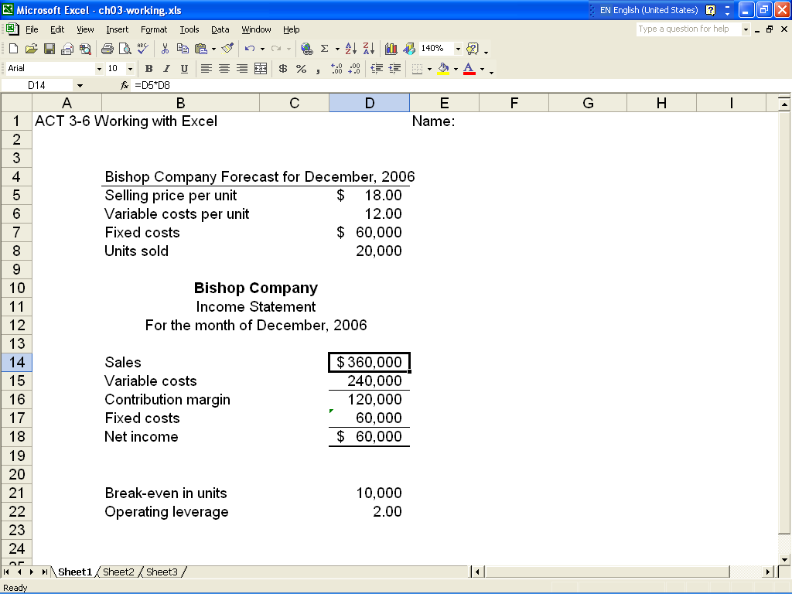

ATC 3-6 (continued)

Screen capture of cell formulas:

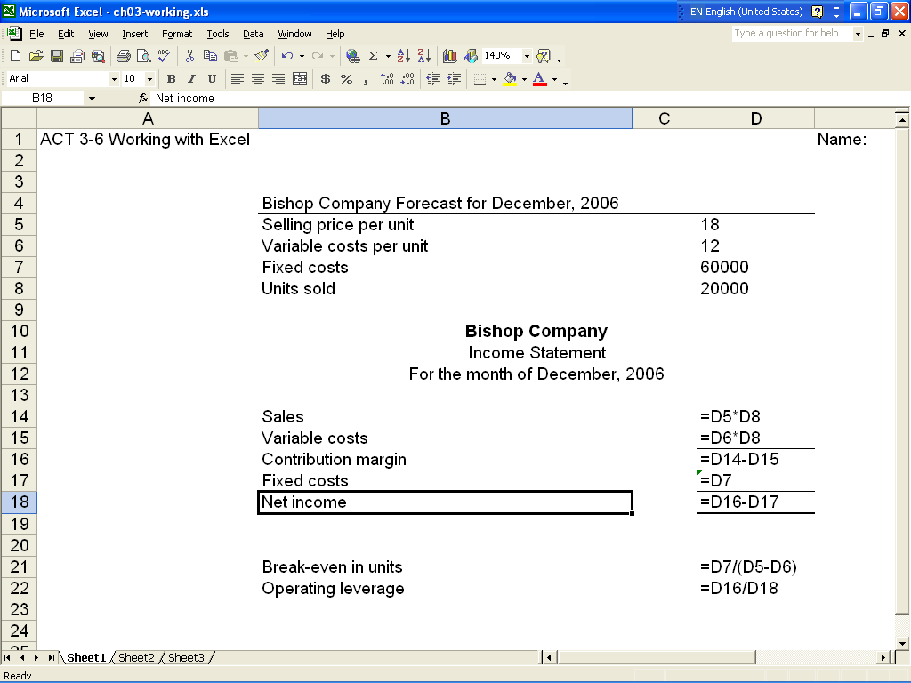

ATC 3-7

Screen of cell values:

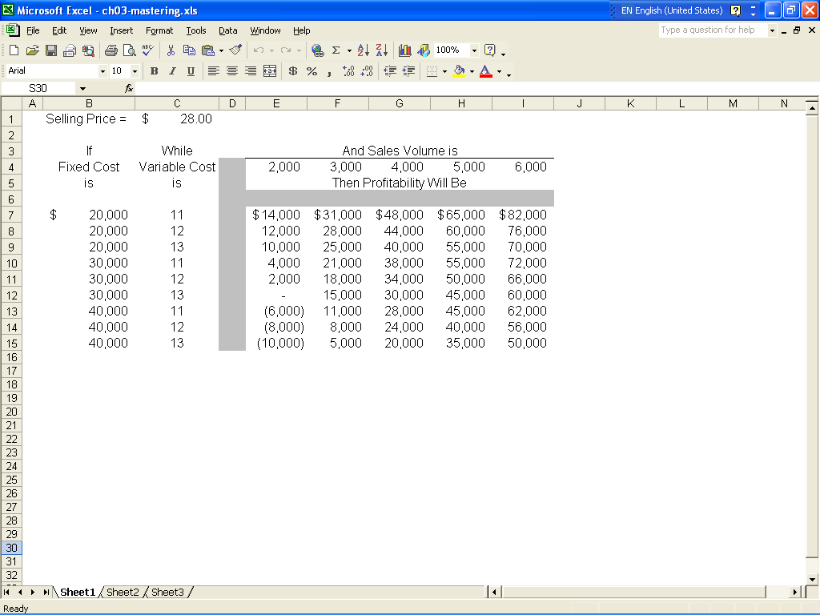

ATC 3-7 (continued)

Screen of cell formulas:

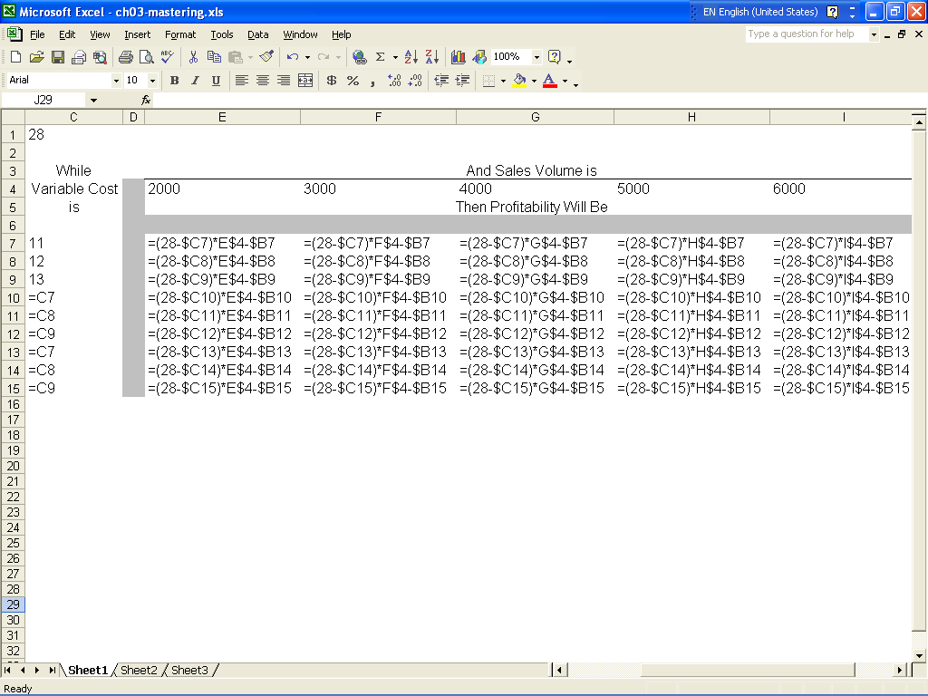

ATC 3-7 (continued)

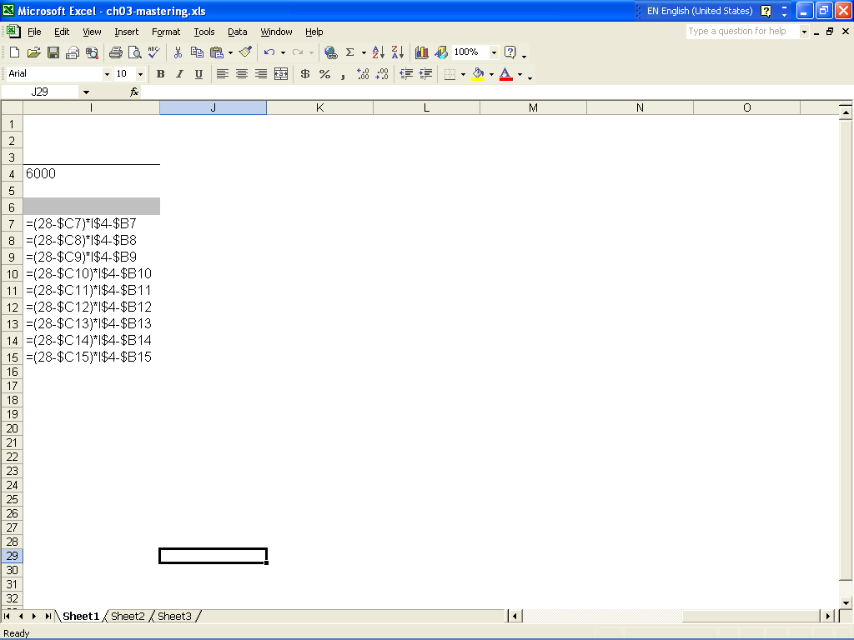

Chapter 3 Comprehensive Problem
Requirement a
Magnificent Modems, Inc.
Income Statement
For Year Ended 12/31/06
 | Sales Revenue ($120 x 5,000 units) |  |  |  |  | $600,000
 | Variable Costs
 | Direct Materials ($40 x 5,000 units) |  |  |  | (200,000)
 | Direct Labor ($25 x 5,000 units) |  |  |  | (125,000)
 | Production Supplies ($4 x 5,000 units) |  |  |  | (20,000)
 | Sales Commission ($6 x 5,000 units) |  |  |  | (30,000)
 | Total Variable cost |  |  |  |  | (375,000)
 | Contribution Margin |  |  |  |  | 225,000
 | Fixed costs
 | Depreciation on Manufacturing Equip. |  |  |  | (60,000)
 | Rent for Manufacturing Facility |  |  |  | (50,000)
 | Depreciation on Administrative Equip. |  |  |  | (12,000)
 | Administrative Expenses |  |  |  | (71,950)
 | Total Fixed cost |  |  |  |  | (193,950)
 | Net Income |  |  |  |  | $31,050

Requirement b
 | Break-even in units
 | Fixed cost |  |  | $193,950
 | ----------------------------- |  | = | -------------- | = | 4,310 | units
 | Contribution margin |  |  | $45
 | Break-even in dollars
 | 4,310 units x $120 = $517,200

Requirement c
 | Budgeted sales - Break-even sales |  |  |  |  | $600,000 - $517,200
 | ---------------------------------------------------- = |  |  |  |  | ------------------------------ = 13.8%
 |  | Budgeted sales |  |  |  | $600,000

